**Running a Docker Image on AWS using AWS ECR and ECS**

**Pre-Requisites**

* Docker should be installed on your system: - To install it follow the [LINK](https://docs.docker.com/desktop/install/windows-install/).
* You should have AWS CLI on your system and an AWS IAM user created and logged into AWS CLI using that user credentials. To do the same follow the steps: -
  + Download and Install AWS CLI: - [LINK](https://docs.aws.amazon.com/cli/latest/userguide/getting-started-install.html)
  + Create IAM user with Administrator policy: - [LINK](https://docs.aws.amazon.com/streams/latest/dev/setting-up.html).
  + Config AWS CLI with AWS IAM credentials: -

Command: - “aws configure”

* Create a react application and build it.
* Now create a Dockerfile with the following content: -

FROM nginx:alpine

COPY build /usr/share/nginx/html

EXPOSE 80

CMD ["nginx", "-g", "daemon off;"]

* If you wish you can build the image now or later in the experiment.

**Part 1: - Upload Image on ECR**

1. Search for a service named: - “Elastic Container Registry”

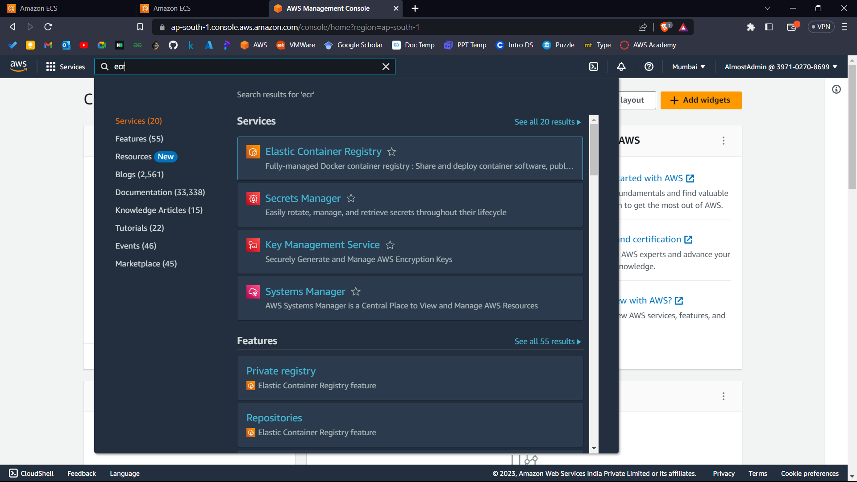



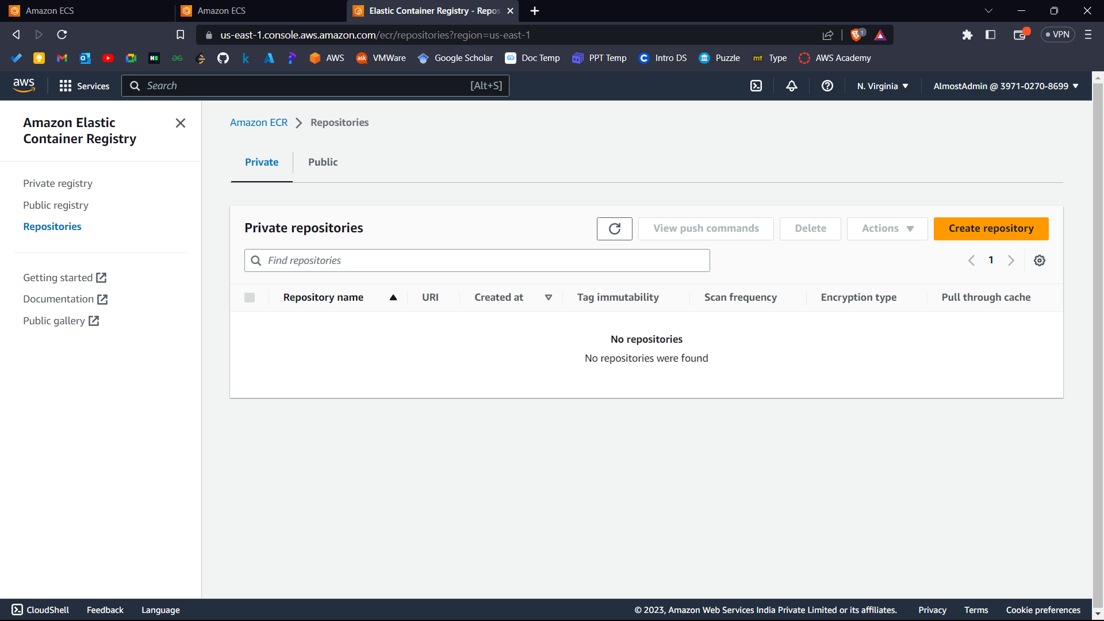



1. Now click on “Create Repository”.

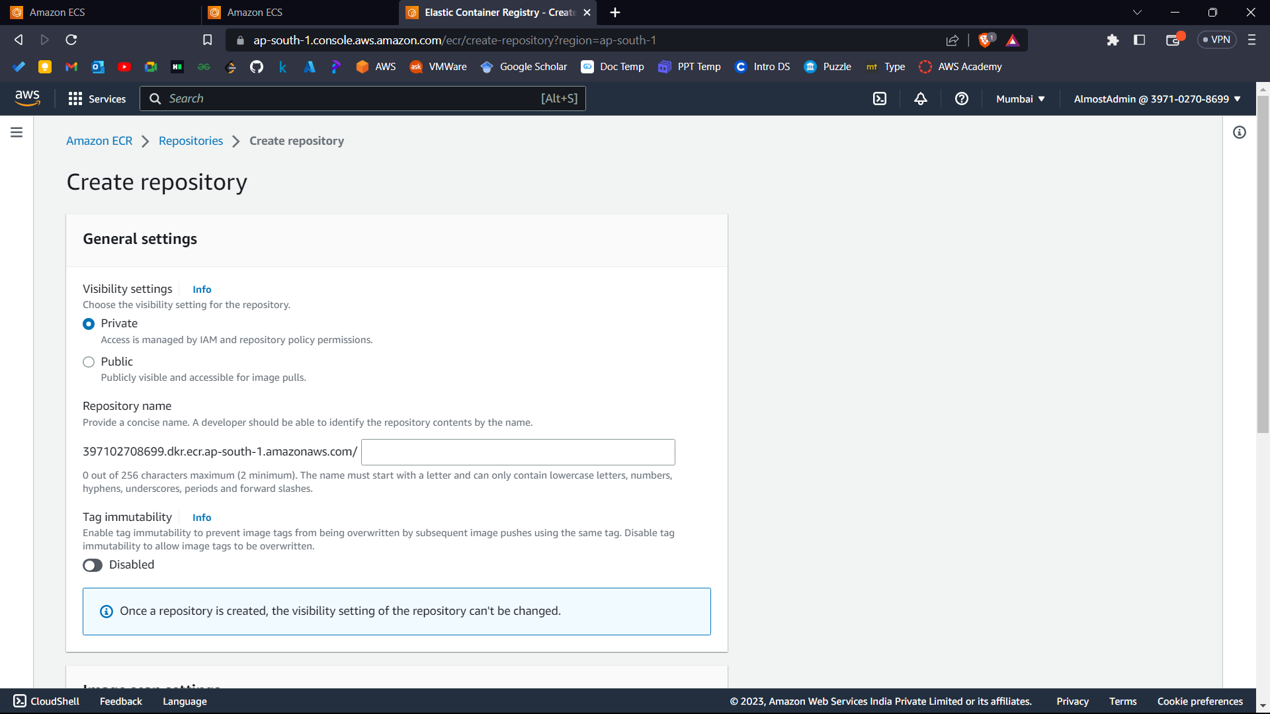



1. Now name your repository and keep rest of the settings on default and click “Create Repository”.

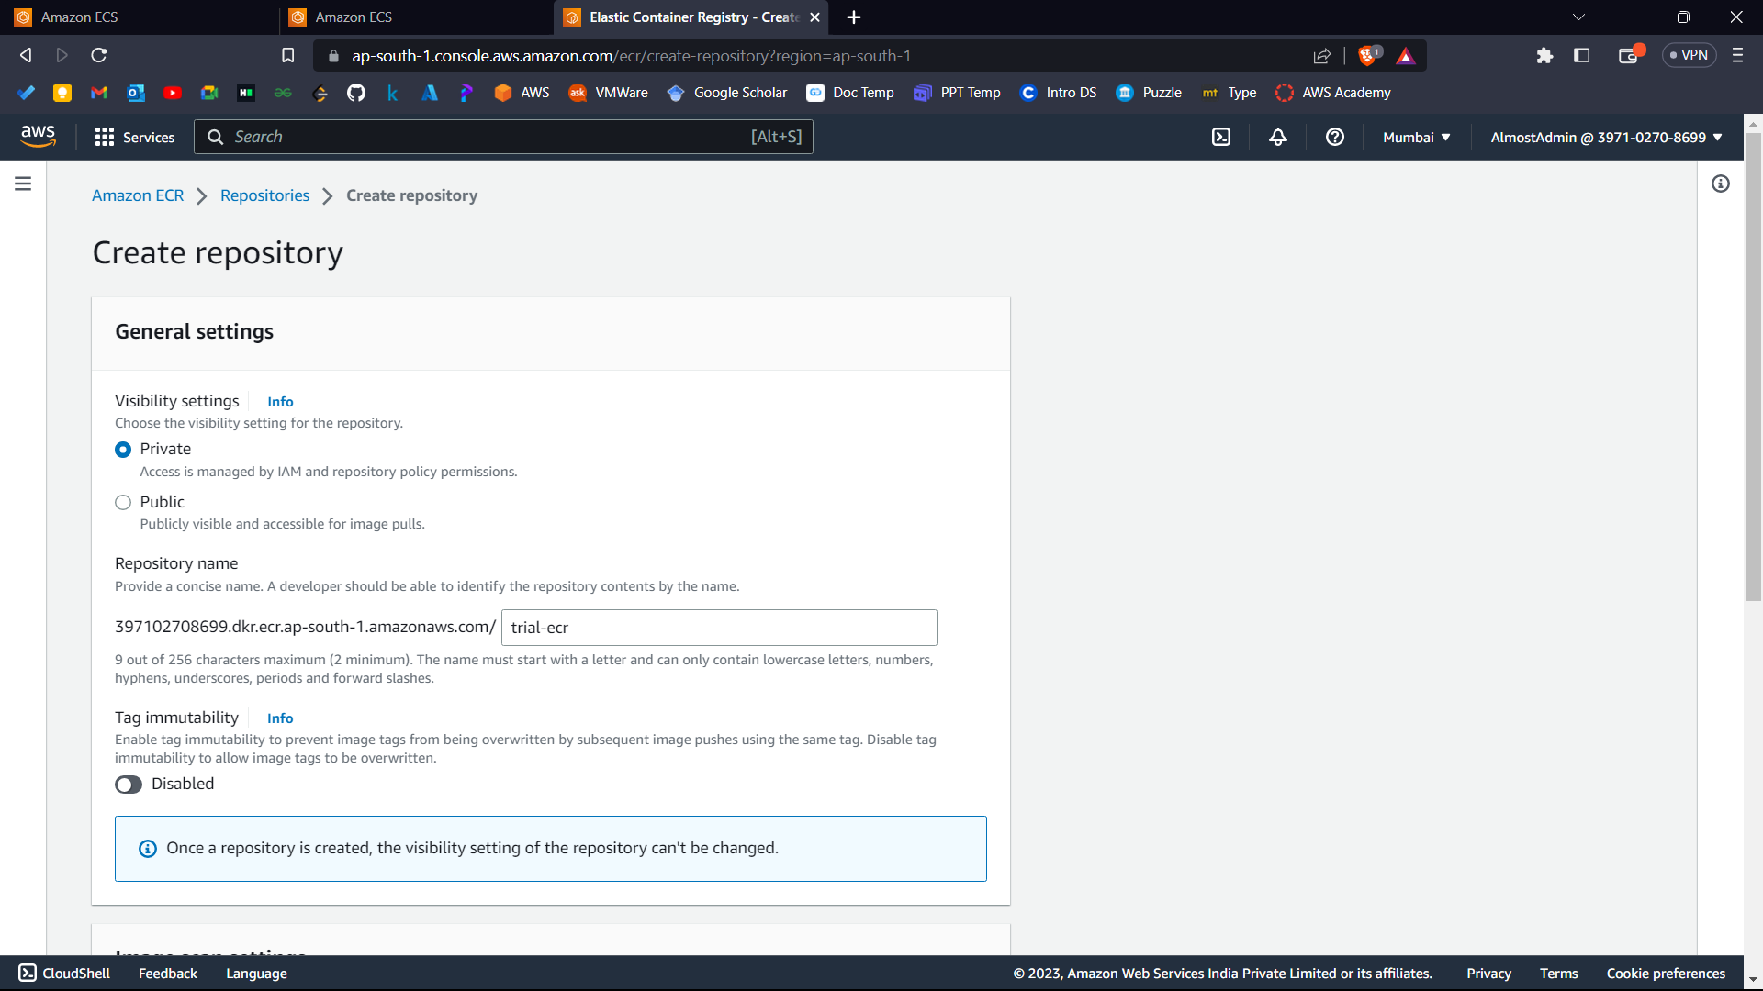



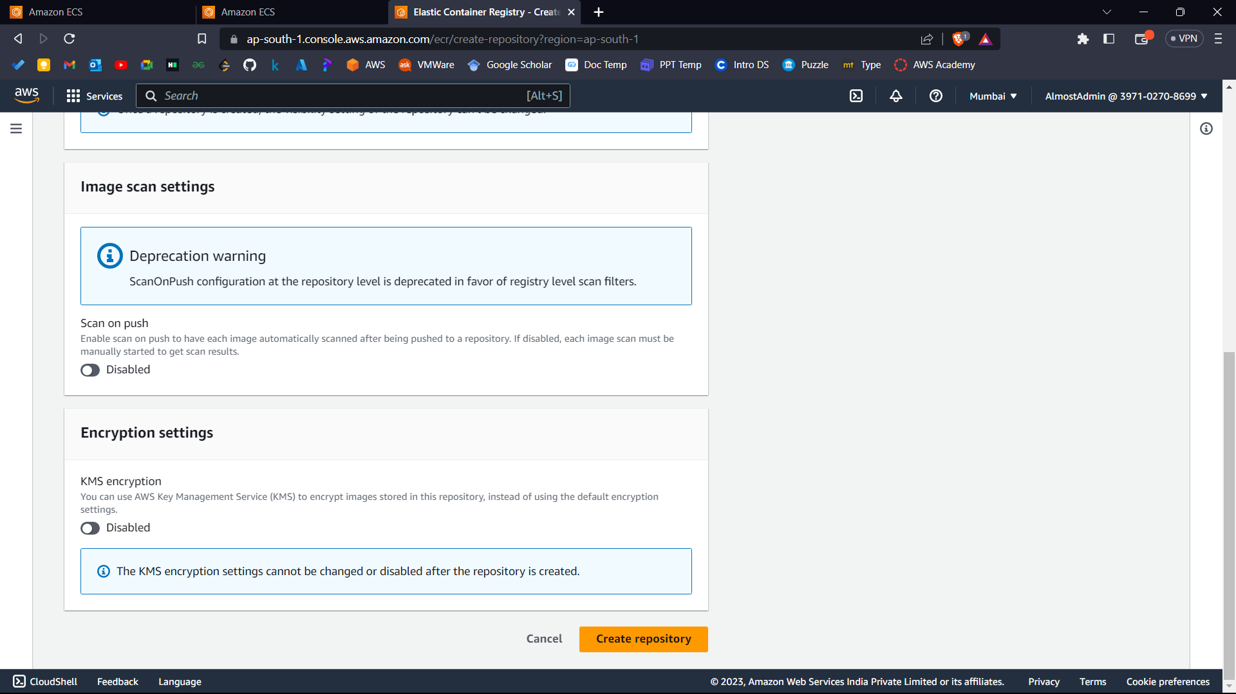



1. Now click and open the currently created repo from the list of repositories.

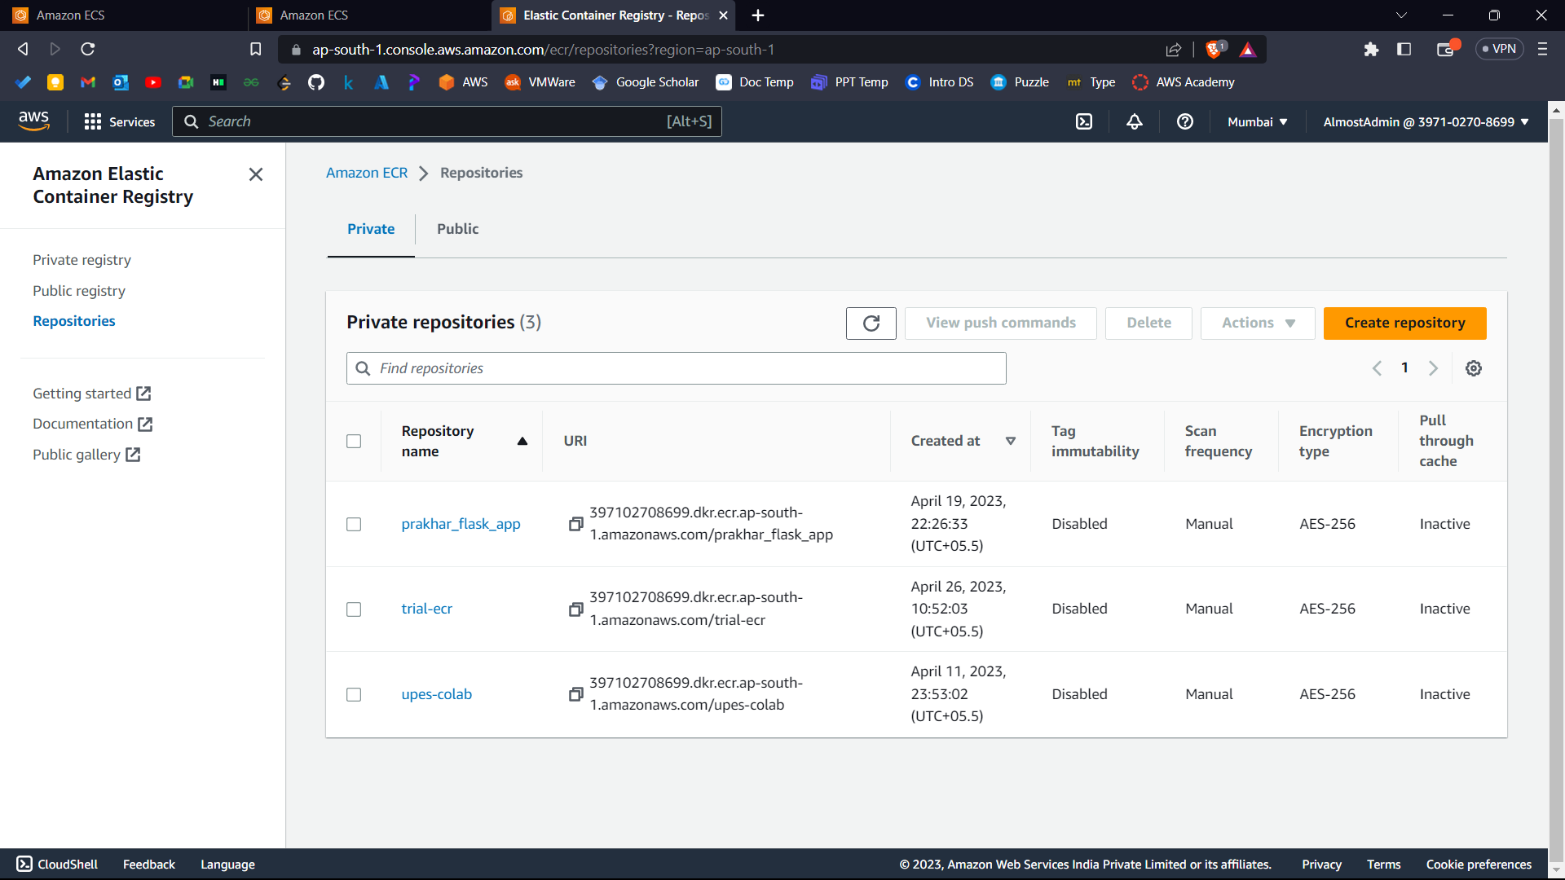



1. Now click on view push commands.

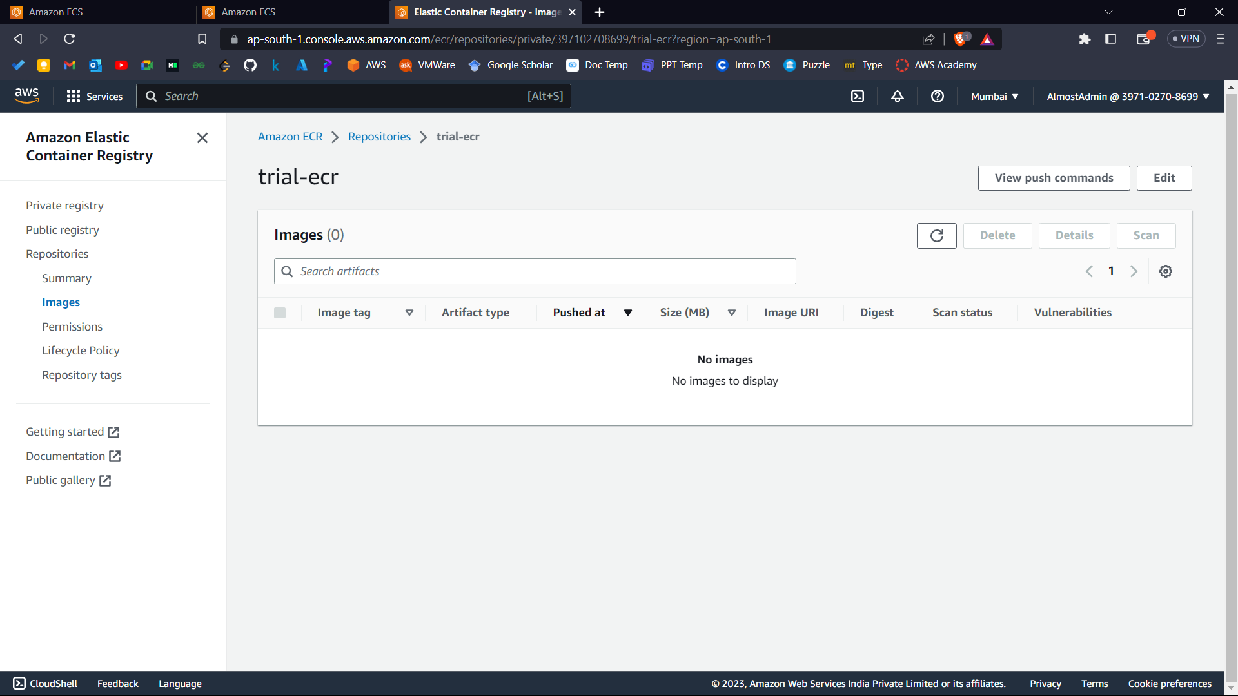



You can use these commands to push your docker image to ECR.

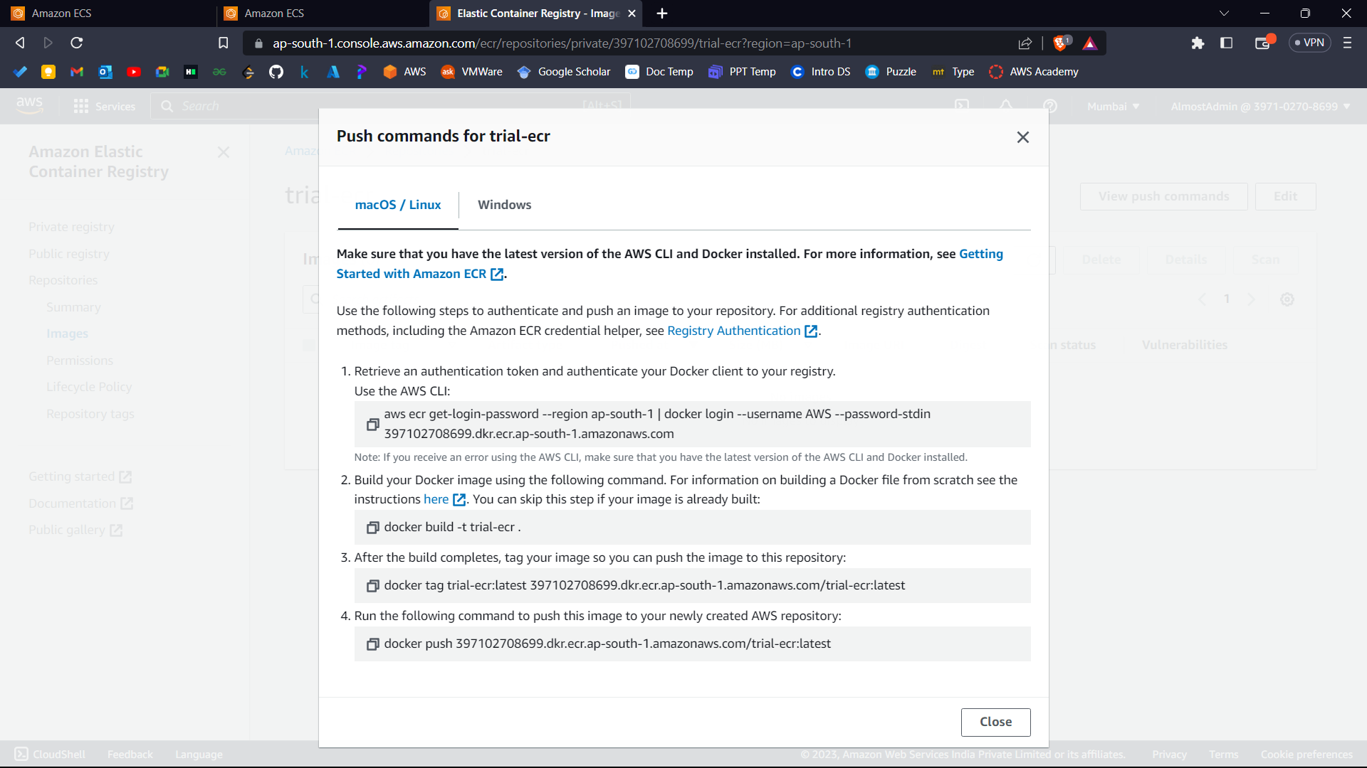



1. Now firstly launch docker desktop on your system once to start the docker engine.

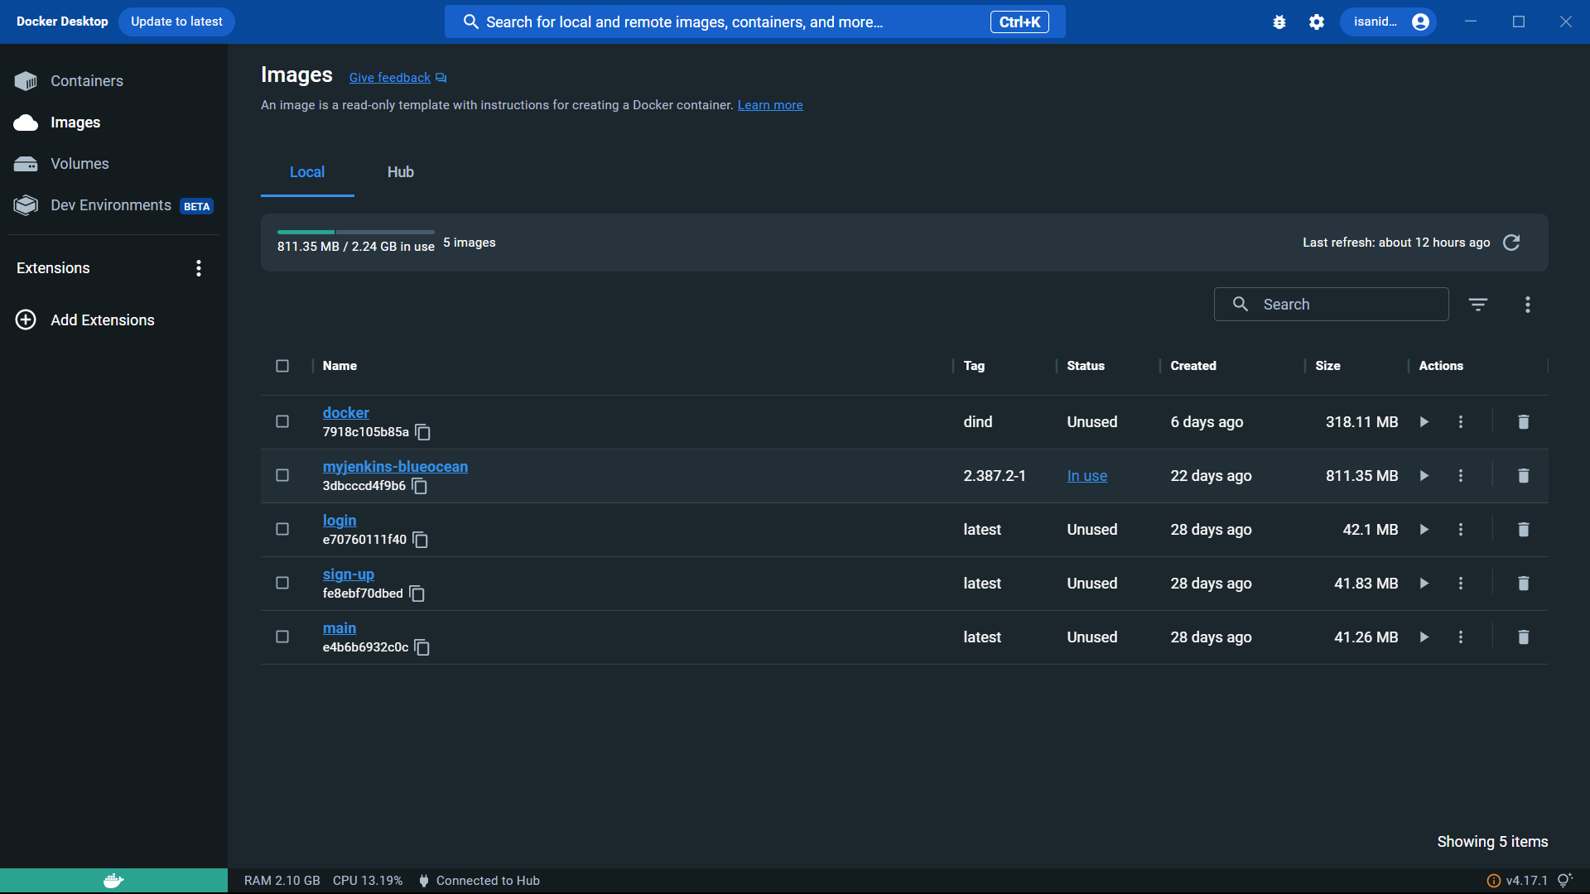

1. Now open terminal on your system and run the commands as per the instructions.

To list the docker images on your system: - “docker images”

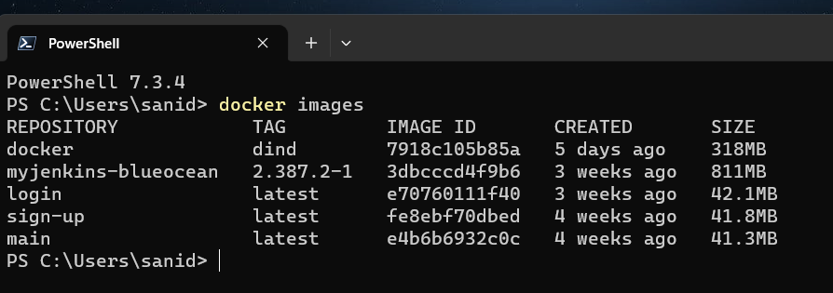

Now decide which image you want to push then run the ECR push commands provided by AWS with a bit of manipulations as mentioned.

Commands you’ll get from AWS: -

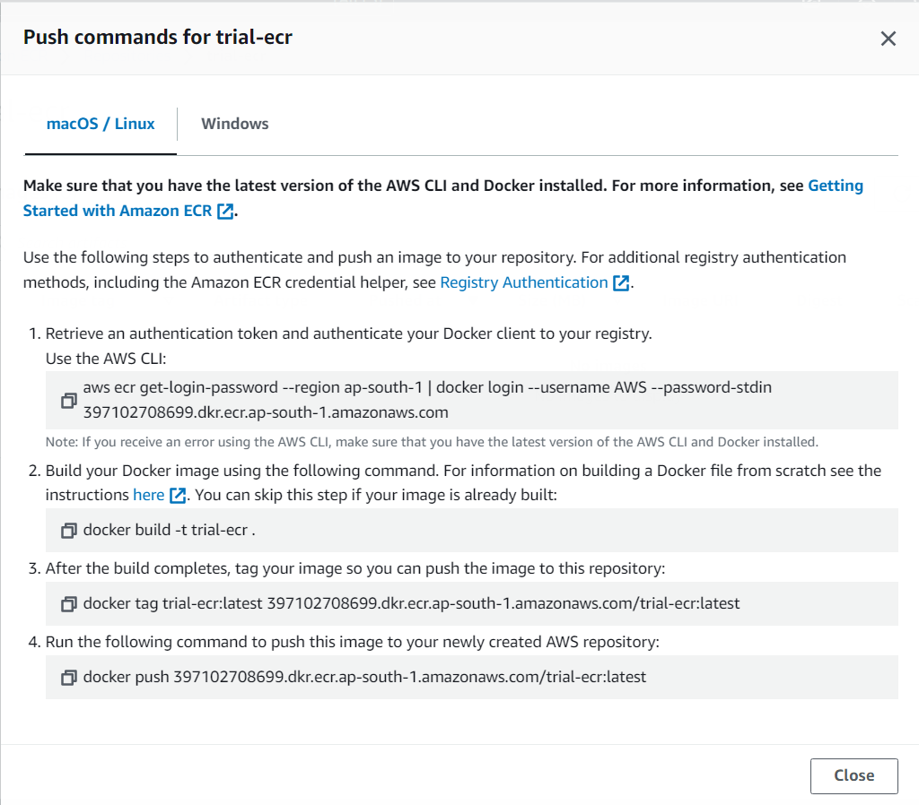



1. Run commands in terminal as per the instructions.
2. Command: -

aws ecr get-login-password --region ap-south-1 | docker login --username AWS --password-stdin <Account Id>.dkr.ecr.ap-south-1.amazonaws.com

Instructions: - Replace “<Account Id>” with your AWS account Id on top right corner of AWS console.

You can skip this ii command if the docker image already exists.

1. Command: -

docker build -t <Image Name> .

Instructions: -

In terminal go inside the directory where the Dockerfile exists.

Replace “<Image Name>” with the name you want to give to your image and run the command and wait for it to build the image.

1. Command: -

docker tag <Image Name>:latest <Account Id>.dkr.ecr.ap-south-1.amazonaws.com/<Repo Name>:<Image Name>

Instructions: -

Replace “<Image Name>” with the name you gave to your image.

Replace “<Account Id>” with your account id.

Replace “<Repo Name>” with your repository name.

You can also copy the command from AWS directly and do the respective manipulations.

1. Command: -

docker push <Account Id>.dkr.ecr.ap-south-1.amazonaws.com/<Repo Name>:<Image Name>

Instructions: -

Replace “<Image Name>” with the name you gave to your image.

Replace “<Account Id>” with your account id.

Replace “<Repo Name>” with your repository name.

You can also copy the command from AWS directly and do the respective manipulations.

Your image is now successfully pushed on ECR.

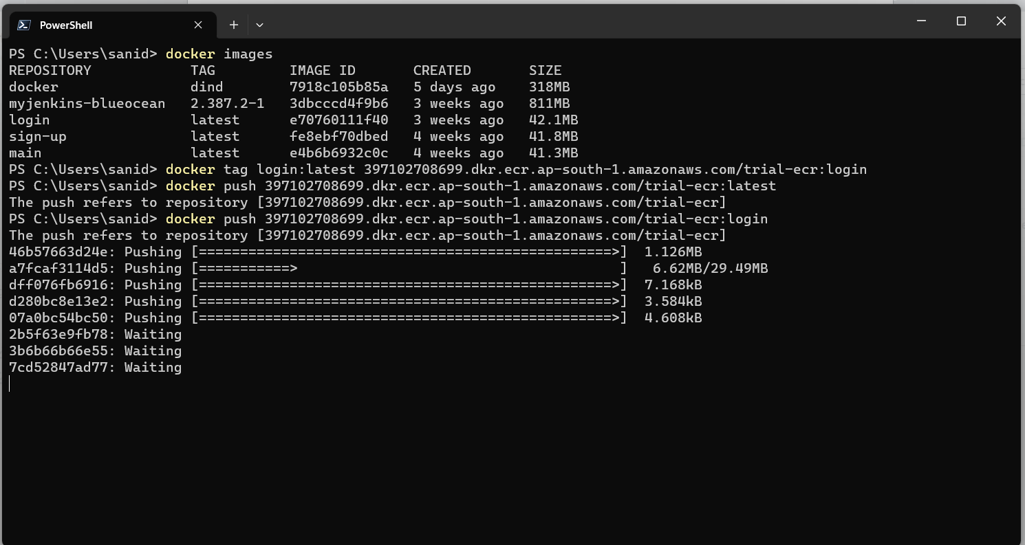



Keep in mind Image URI is visible in over here.

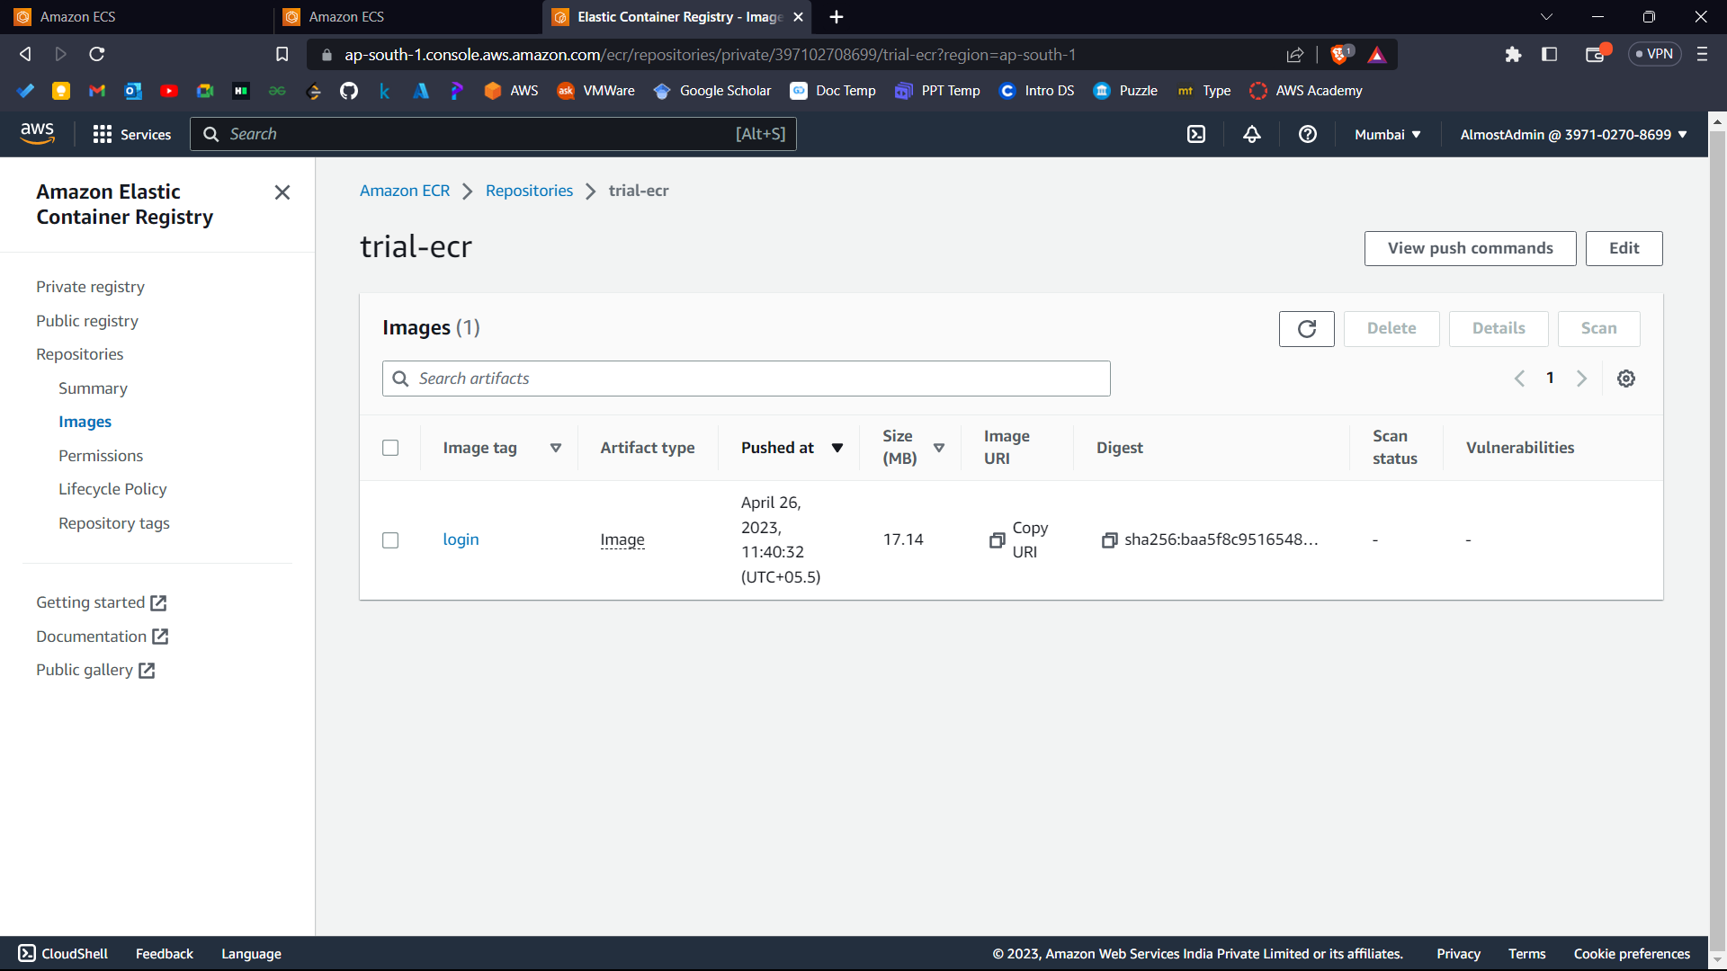



**Part 2: - Create a Task Definition**

1. Go to AWS console and search Elastic Container Service.

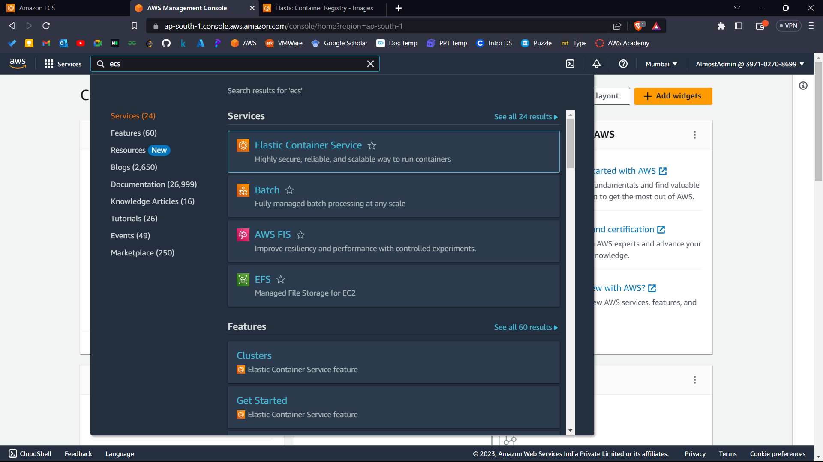



1. Now go to task definitions in left side.

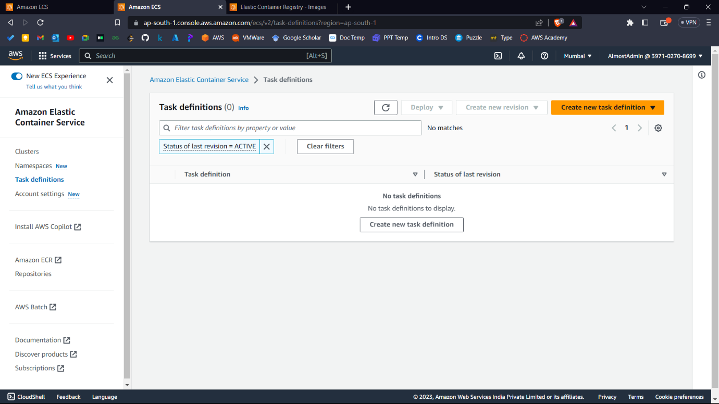



1. Click on Create New Task Definition and select Create New Task Definition.

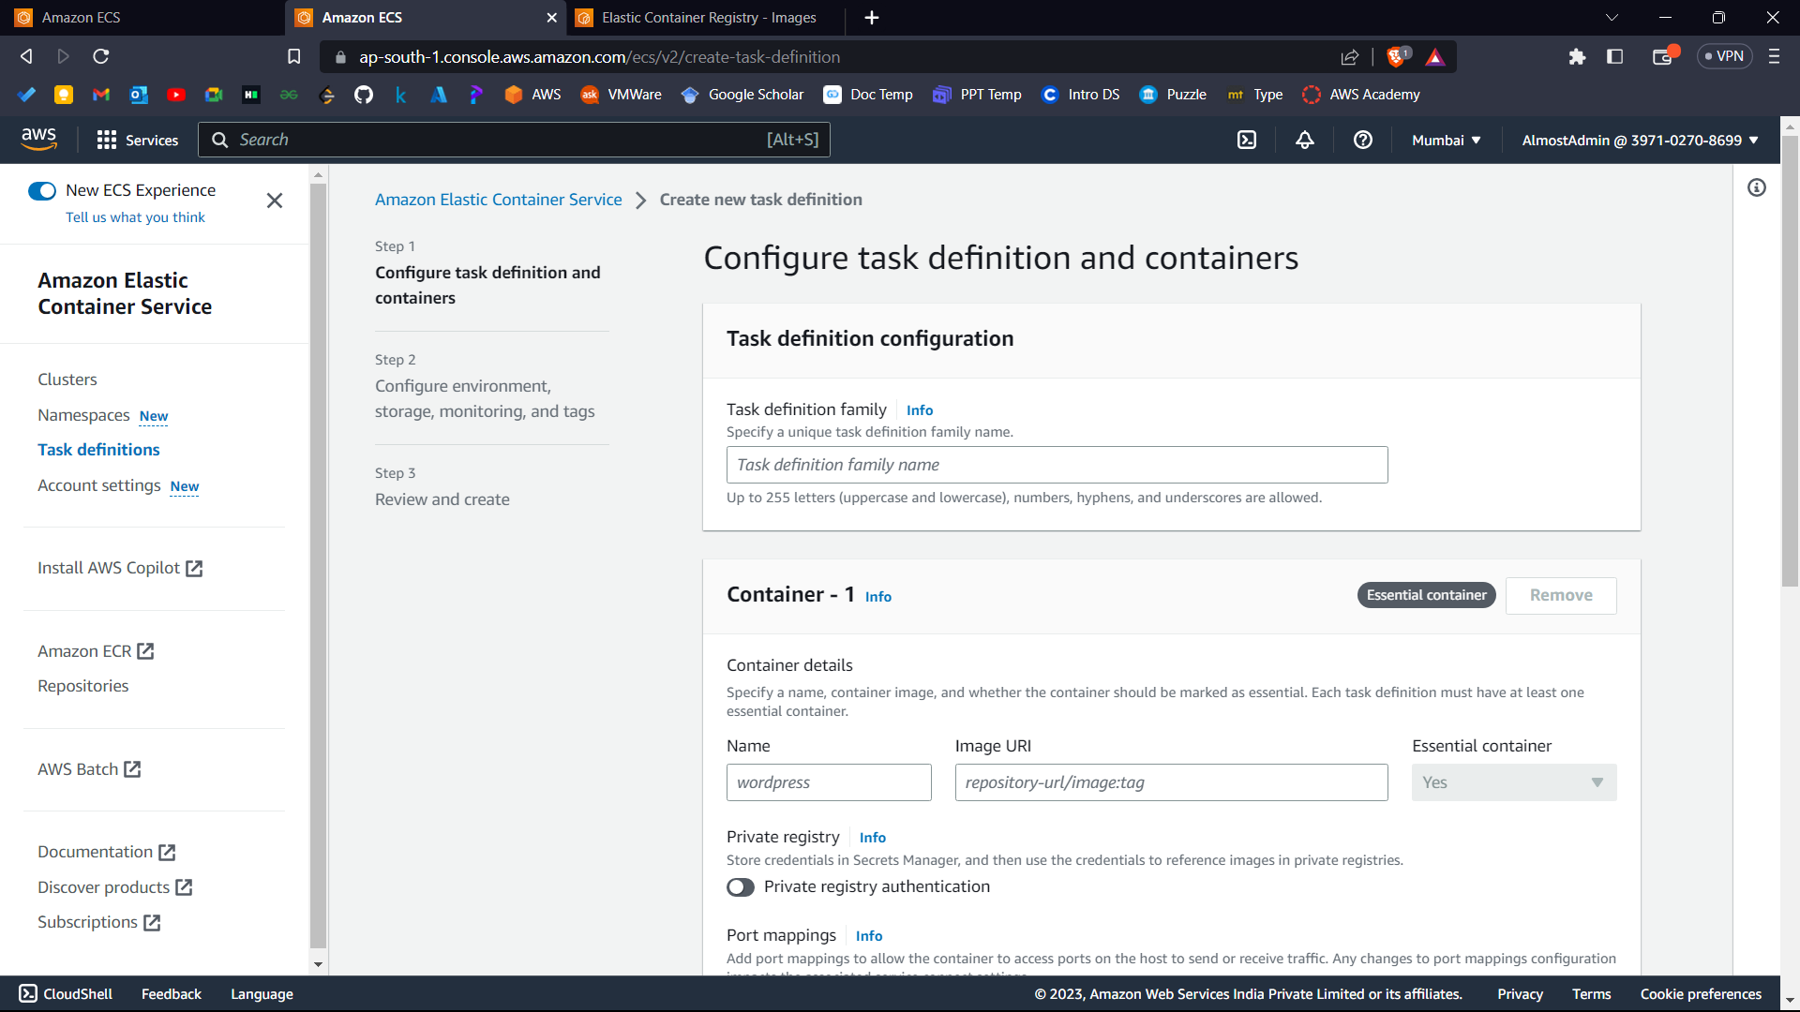



1. Now name your task definition family.
2. Give your container 1 details: -

* Name
* Image URI – Go to AWS ECR inside your repository and copy the image URI of your image as mentioned before to keep in mind.
* In Container Port, set the port on which your docker image runs.
* And keep rest settings to default as shown in screenshots.

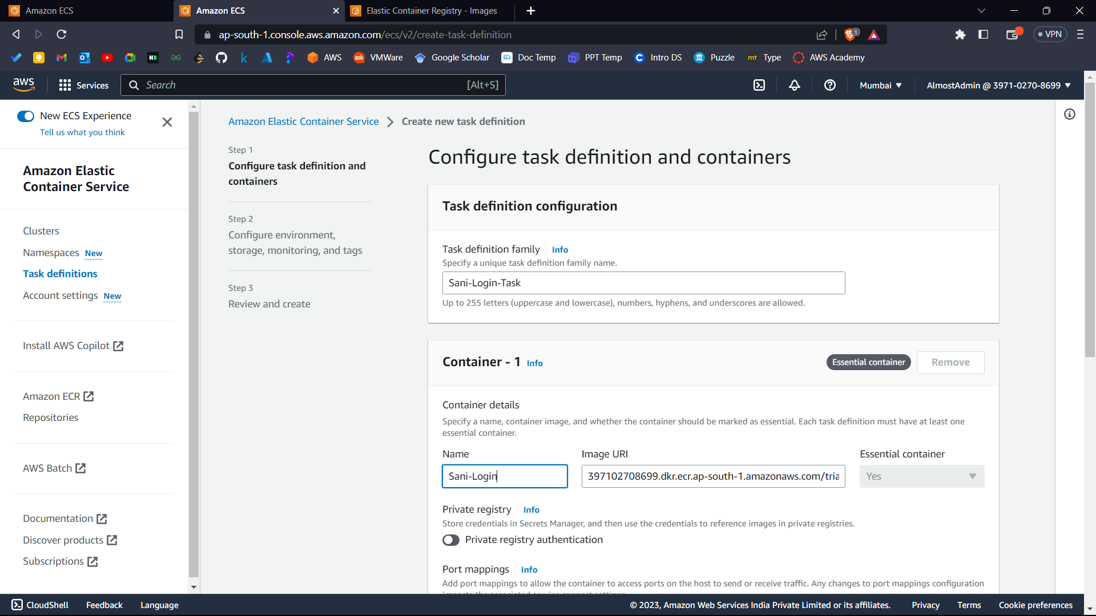



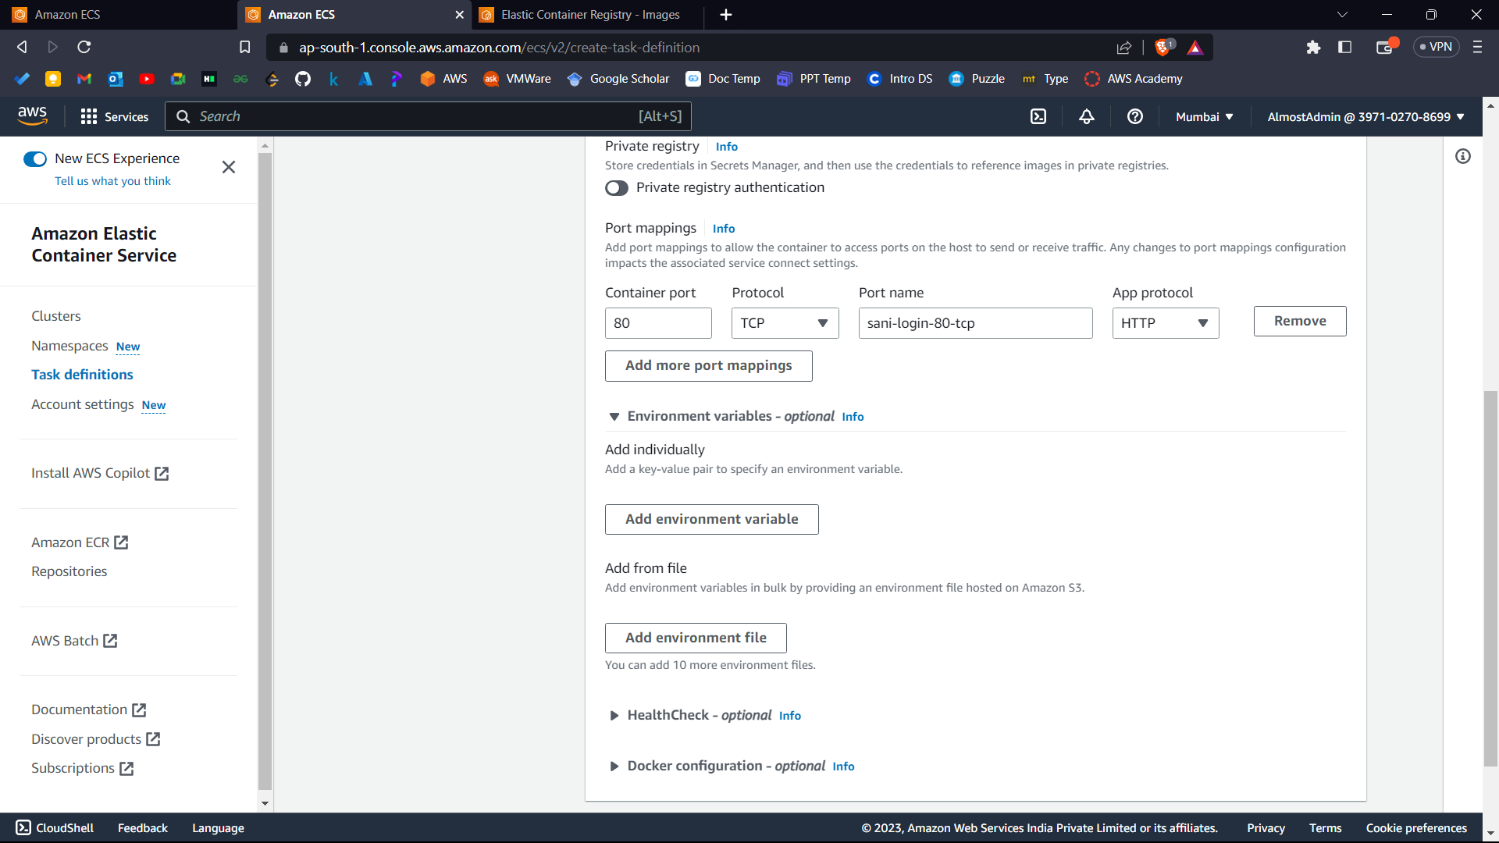

1. Click next.

Now configure the environment.

App environment: - AWS Fargate (Default)

Operating System/Architecture: - Linux/X86_64

Task Size: -

* CPU: - .25 vCPU
* Memory: - .5 GB

Task Role: - None.

Task Execution Role: - ecsTaskExecutionRole. (For the first time it will be created automatically)

Leave below settings to default.

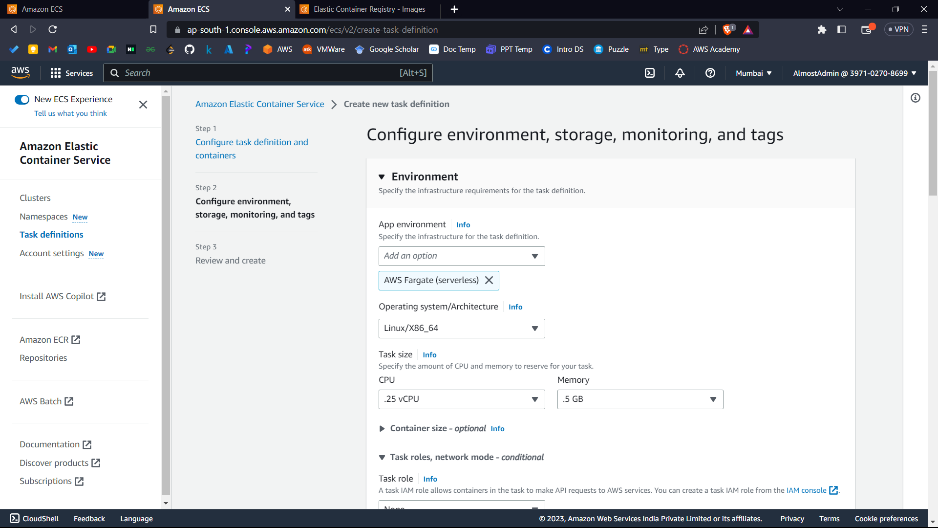

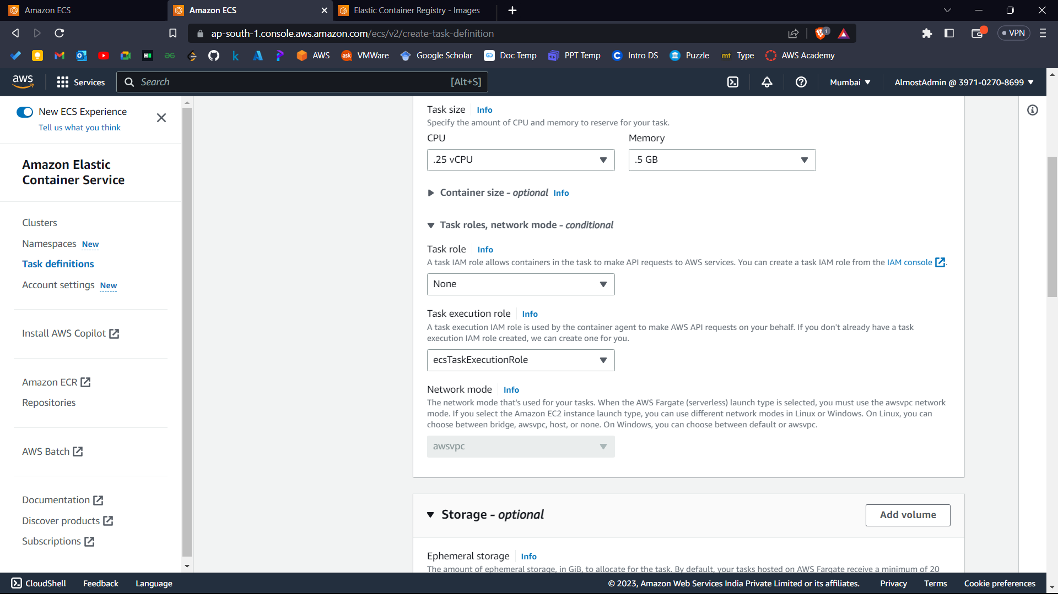

1. Click next.
2. Confirm the configurations and click create.

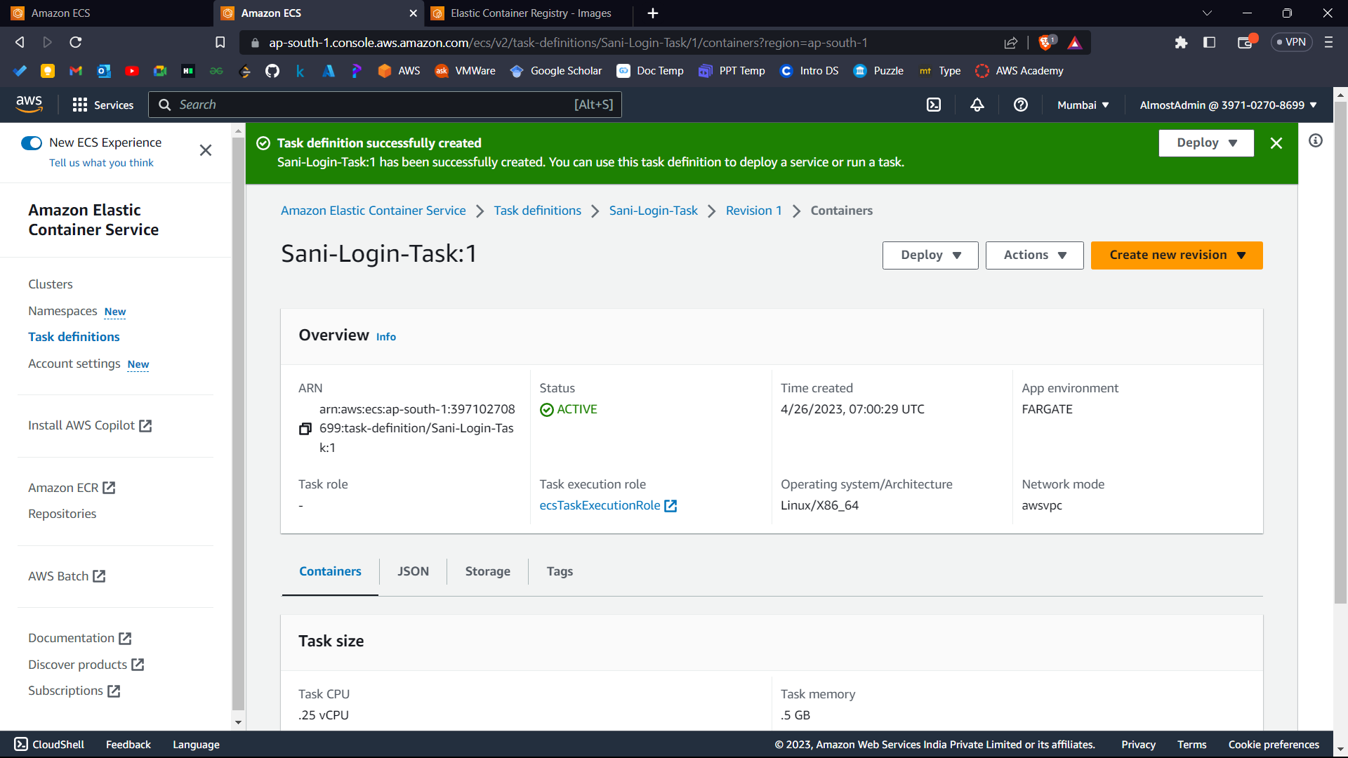



Your Task Definition is created successfully.

**Part 3: - Create a Cluster and Run Task**

1. In Elastic Container Service, go to clusters.

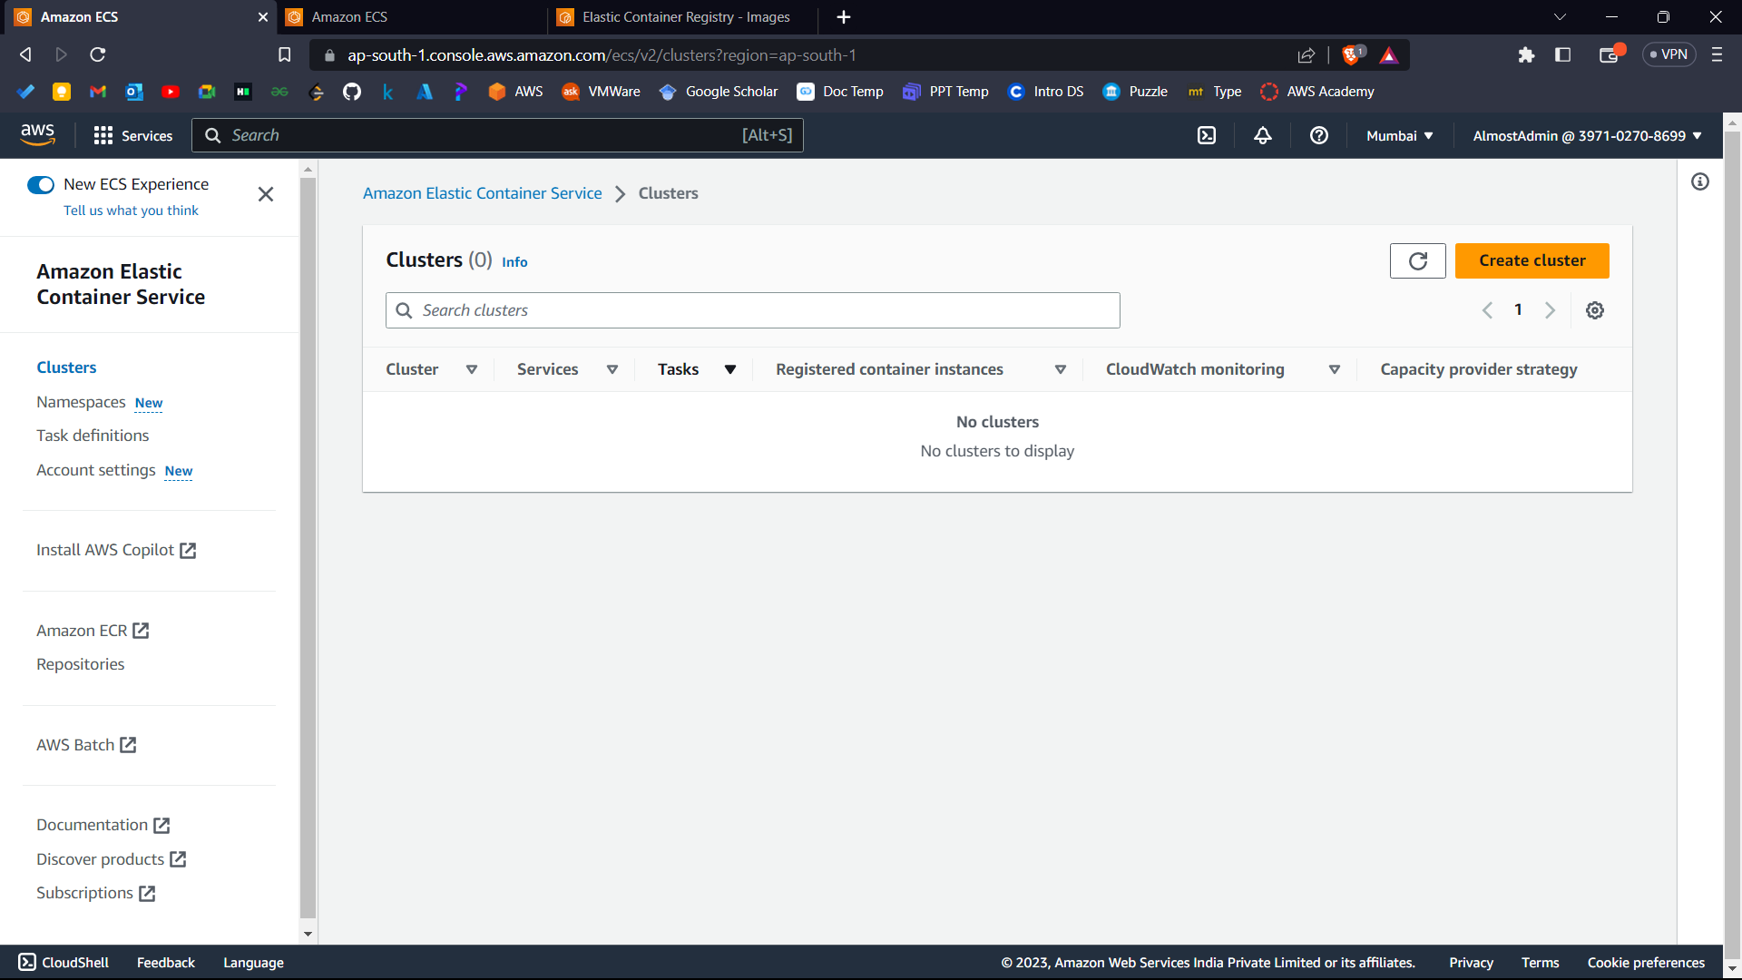



1. Click create cluster.

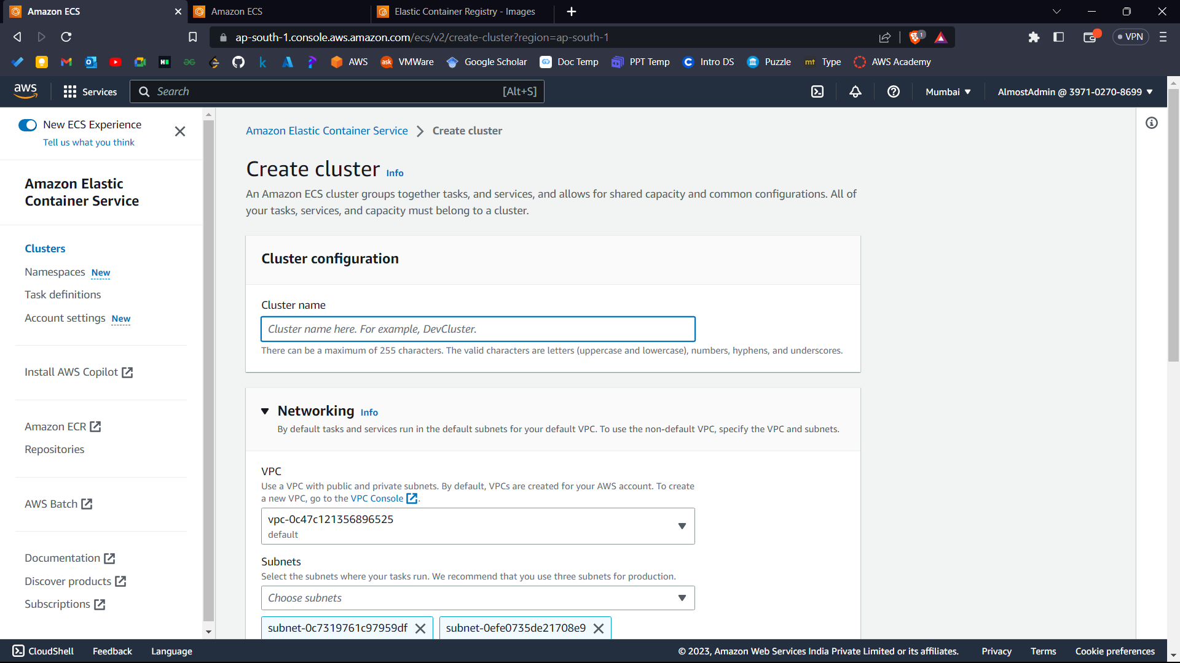



1. Give cluster name.

Keep rest things to default.

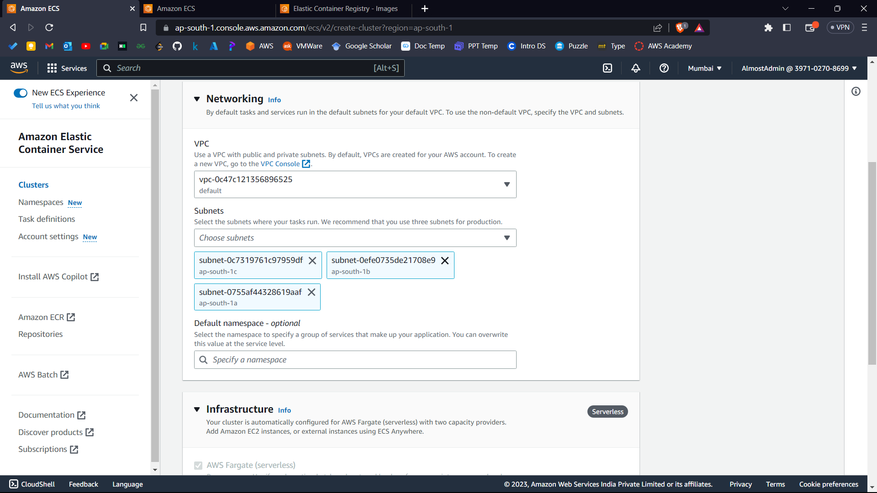



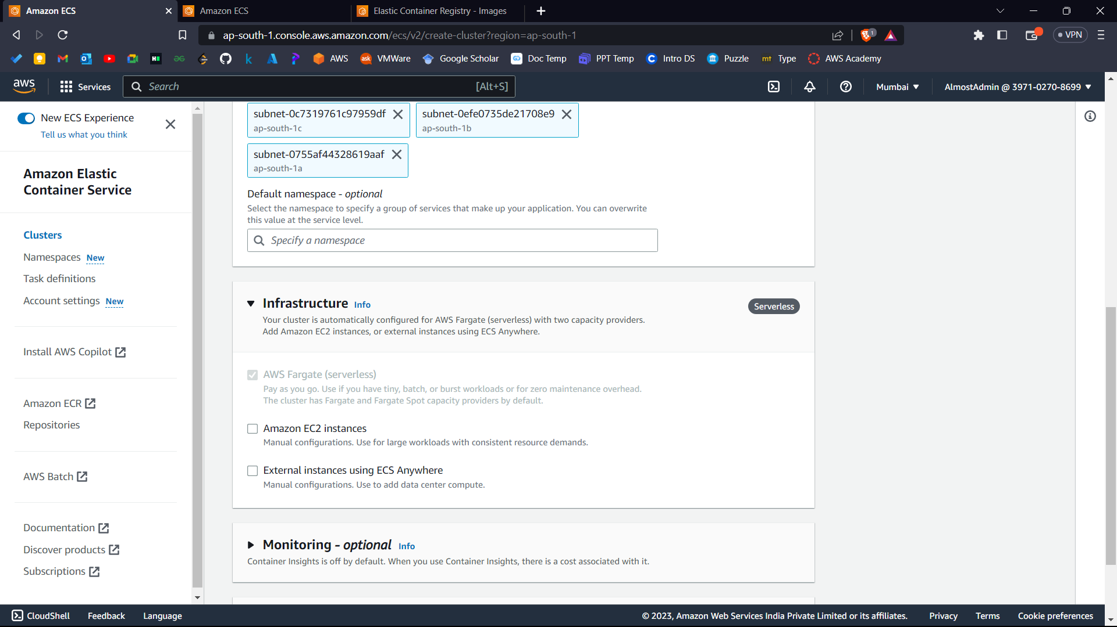



1. Click create.

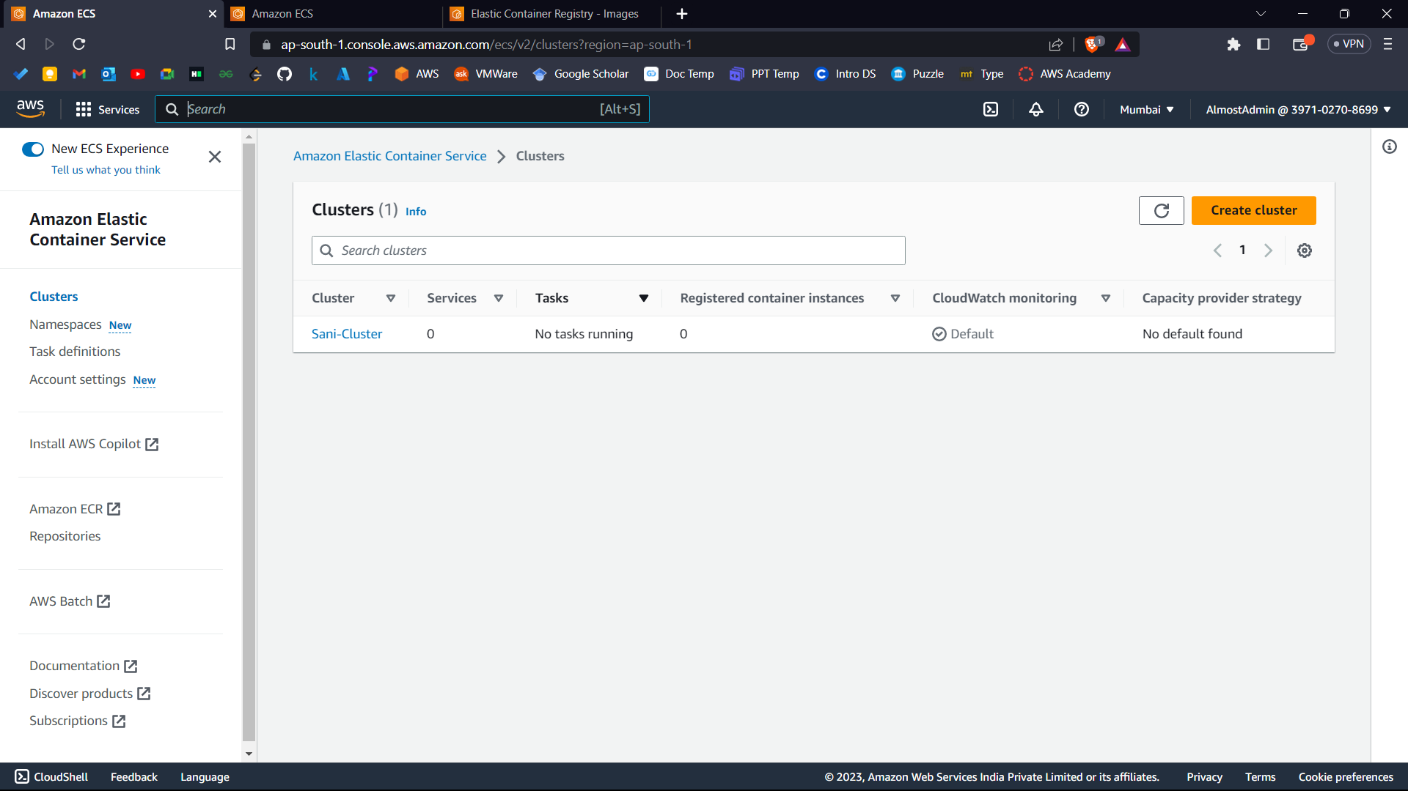



1. Now open the cluster.

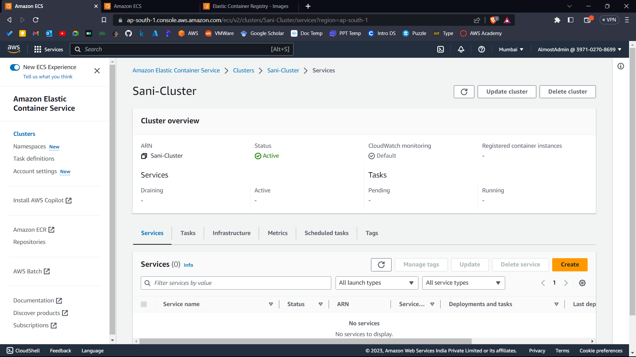



1. Go to tasks.

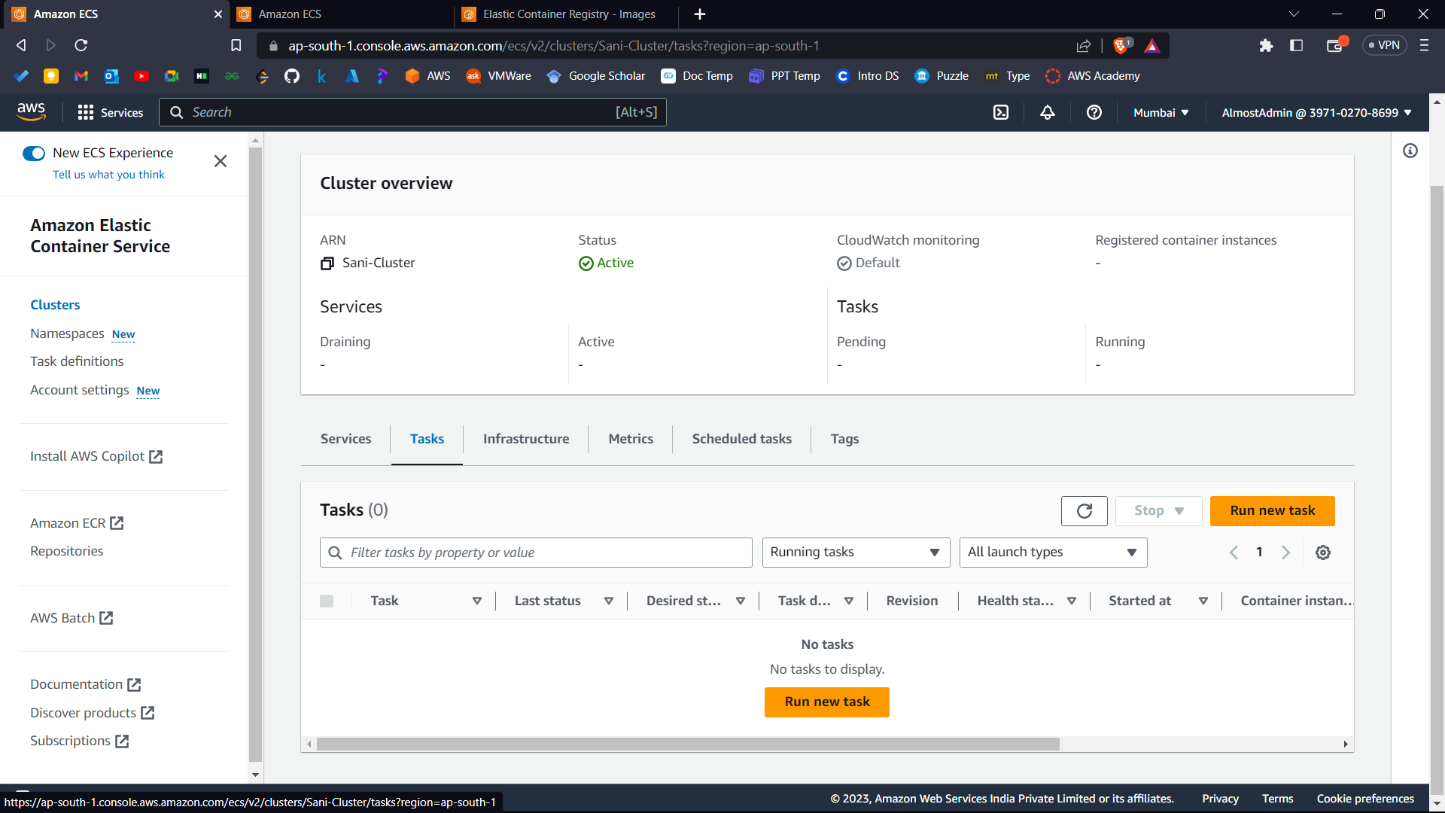



1. Click Run New Task.

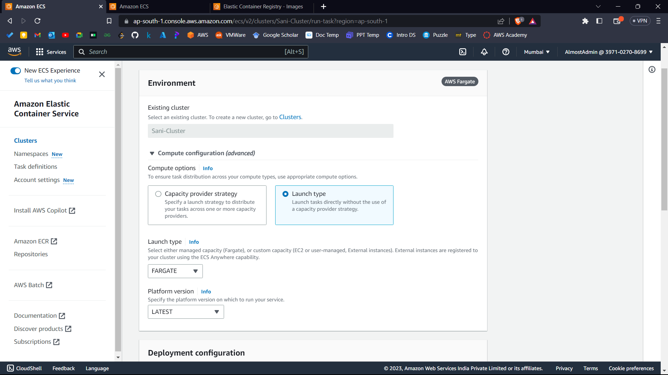



1. Configure according to the instructions: -

Environment: -

Compute options: - Launch Type.

Launch Type: - FARGATE

Platform Version: - LATEST.

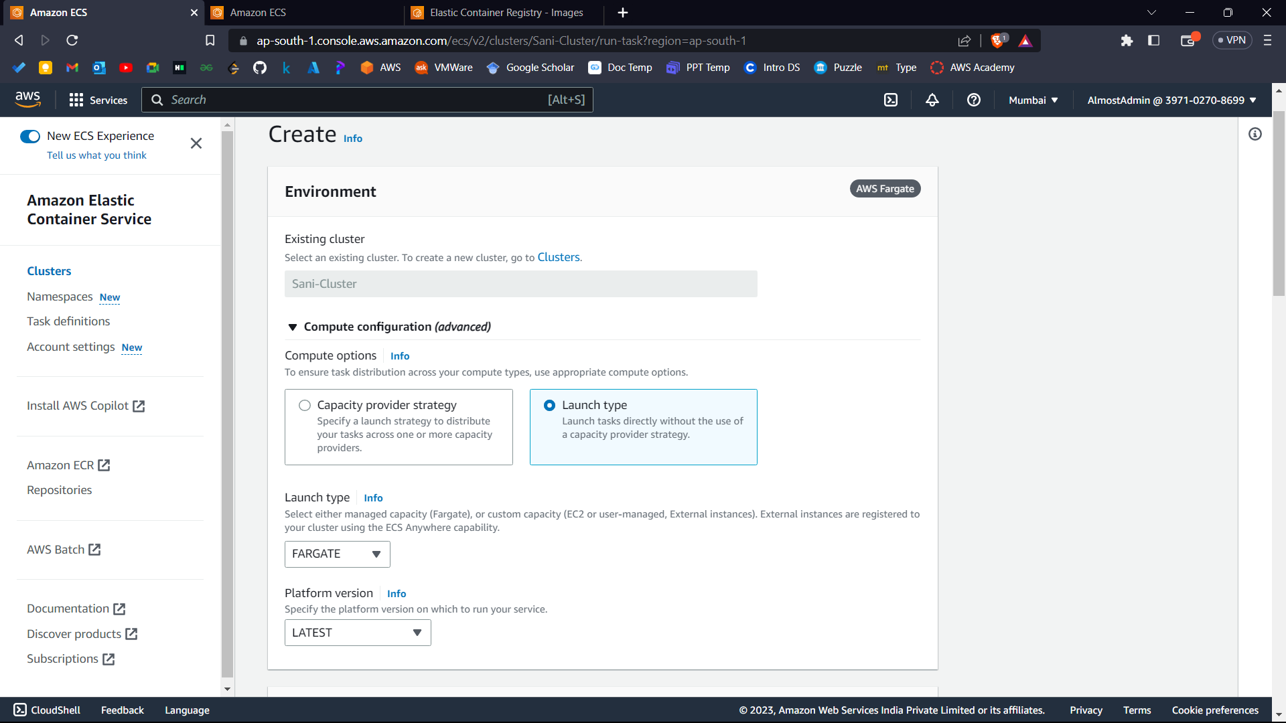



Deployment Configuration: -

Application Type: - Task

Family: - Name of Task Definition you created

Revision: - 1(LATEST) (Default)

Desired Tasks: - 1

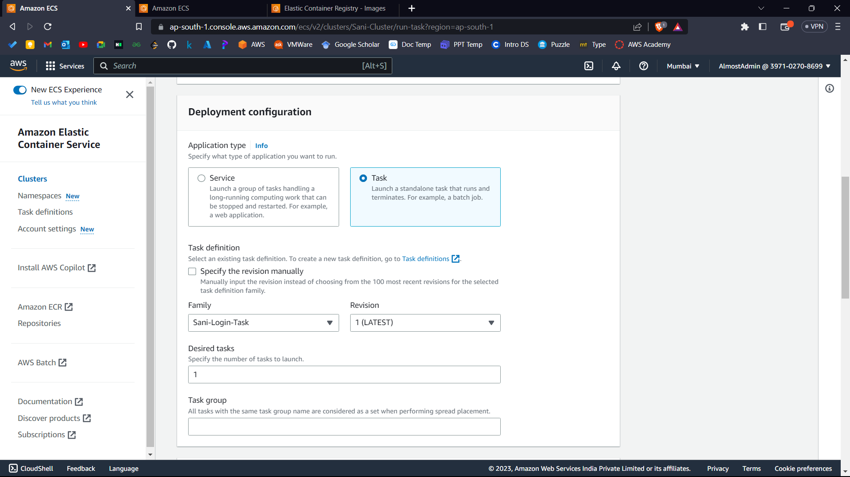



Networking: -

Security Groups: -

Go to AWS console on new tab and search for EC2 and go to security groups.

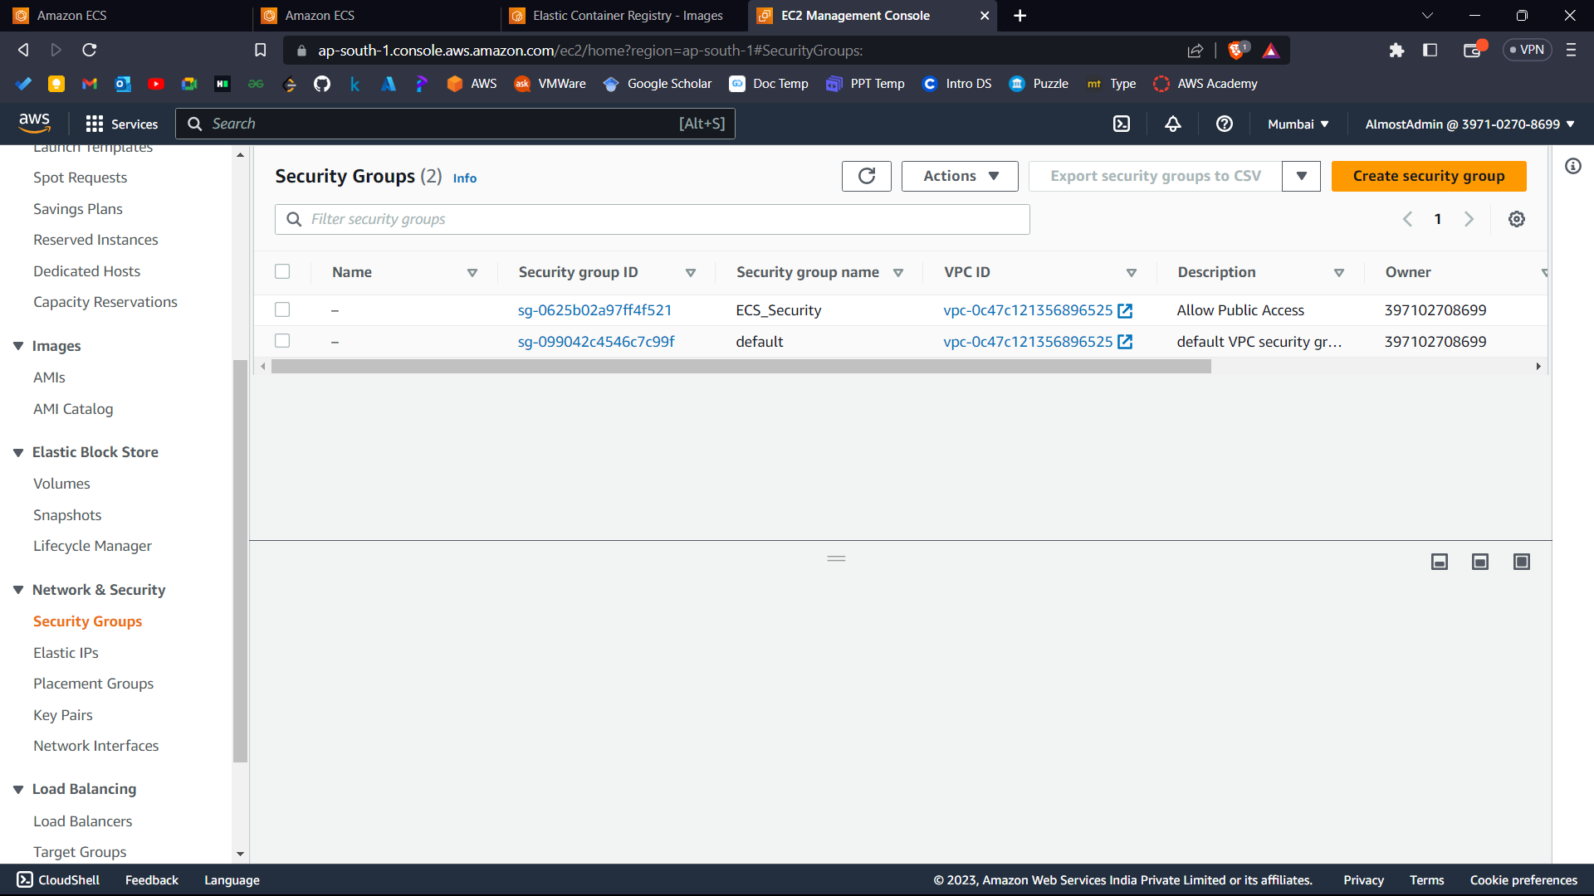



Create a new Security Group.

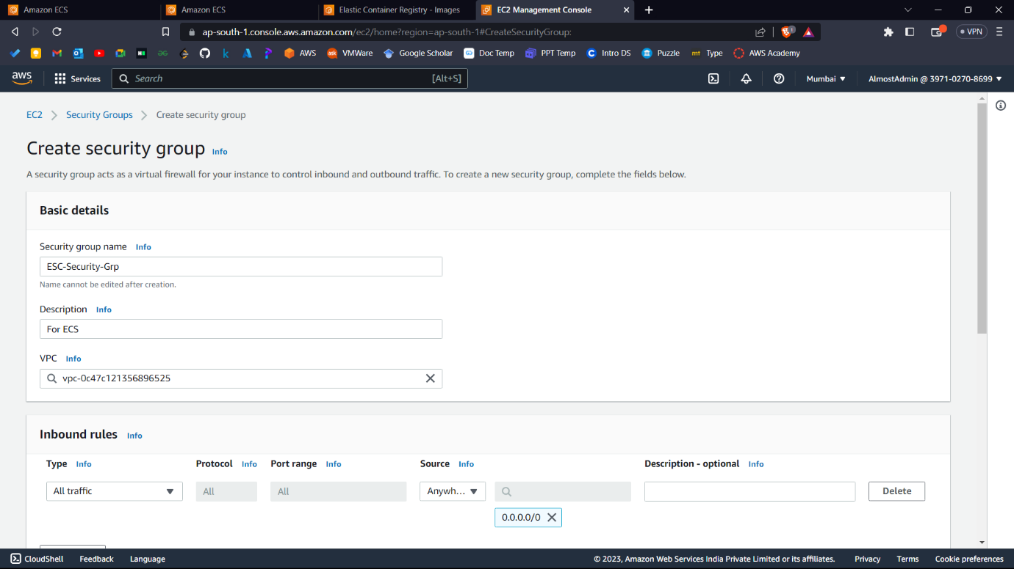



Add an inbound and outbound rule with the following config.

Type: - All Traffic

Source: - Anywhere-IPv4

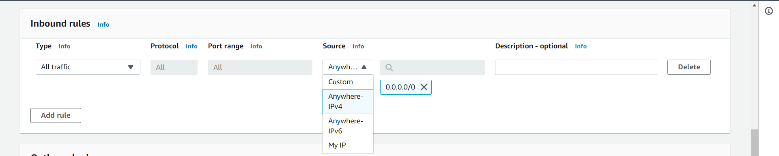

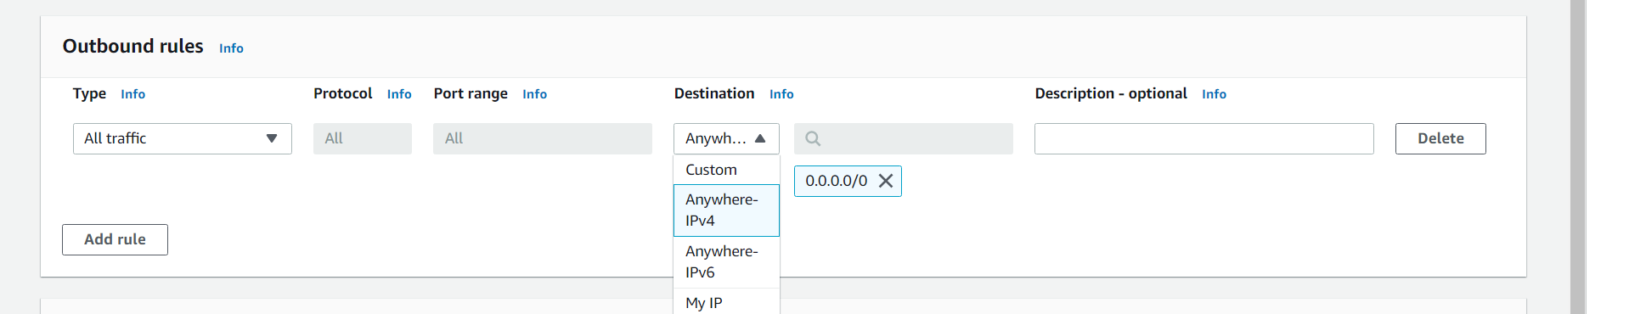

Now again go back to previous tab of ECS.

1. Select security group as the once you created just now. (This would work in further experiments also).

And now click Create.

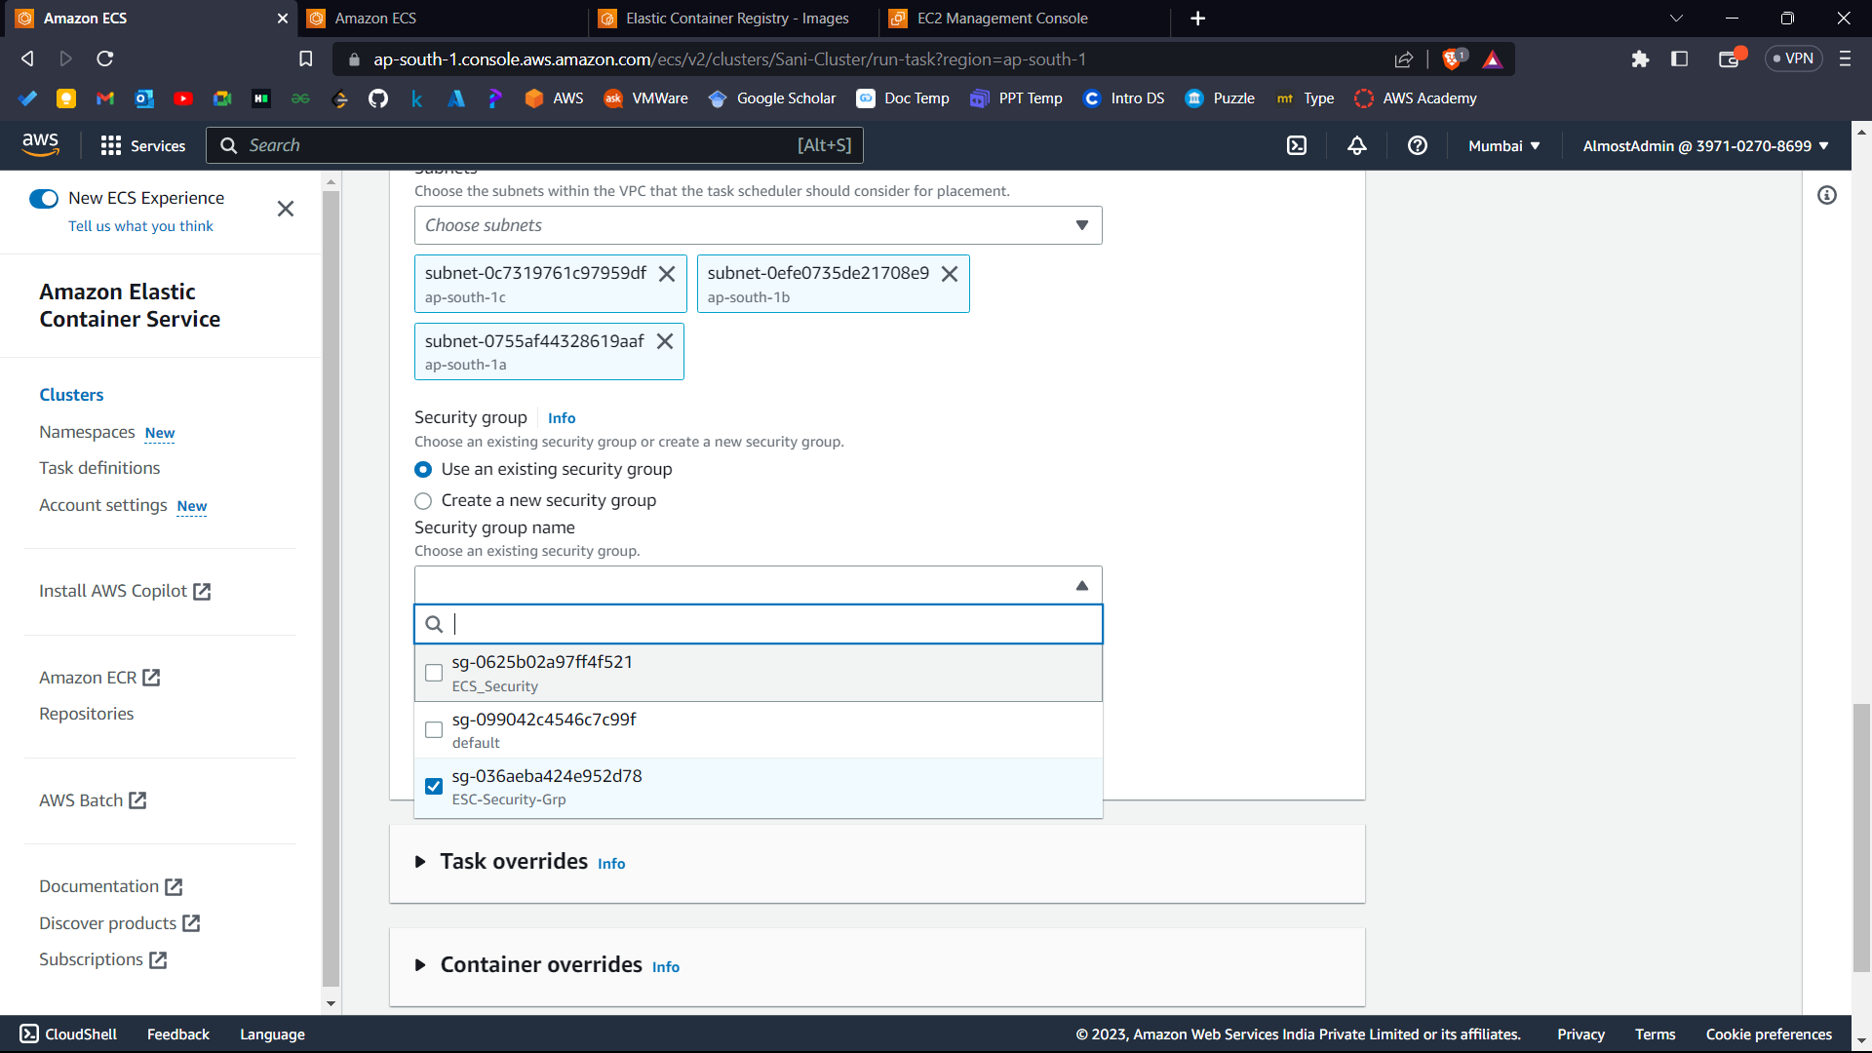



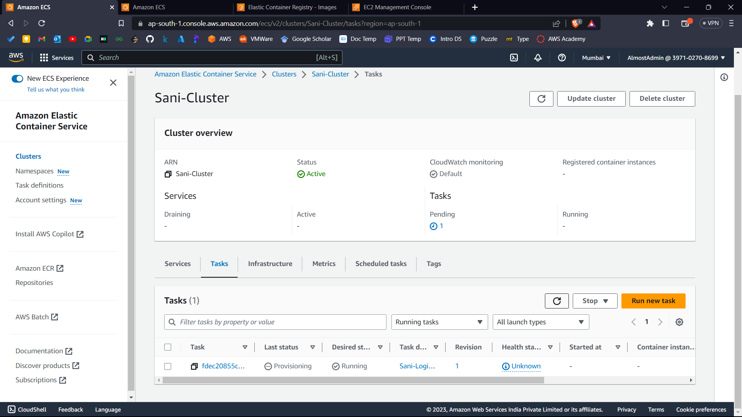



1. Now keep on refreshing until the status is running.

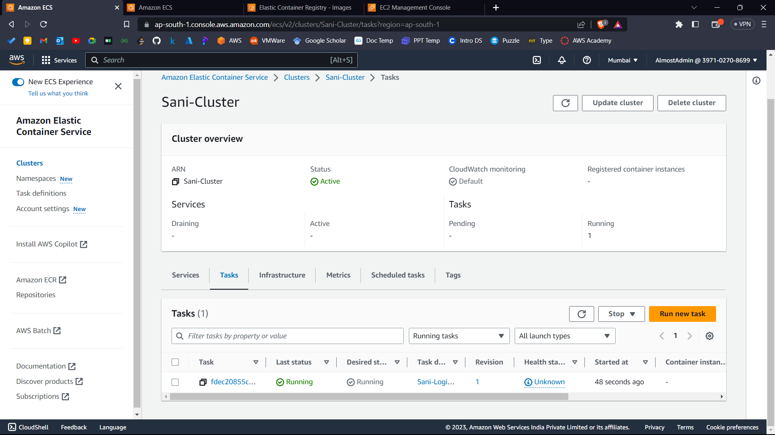



1. Now click on that task.

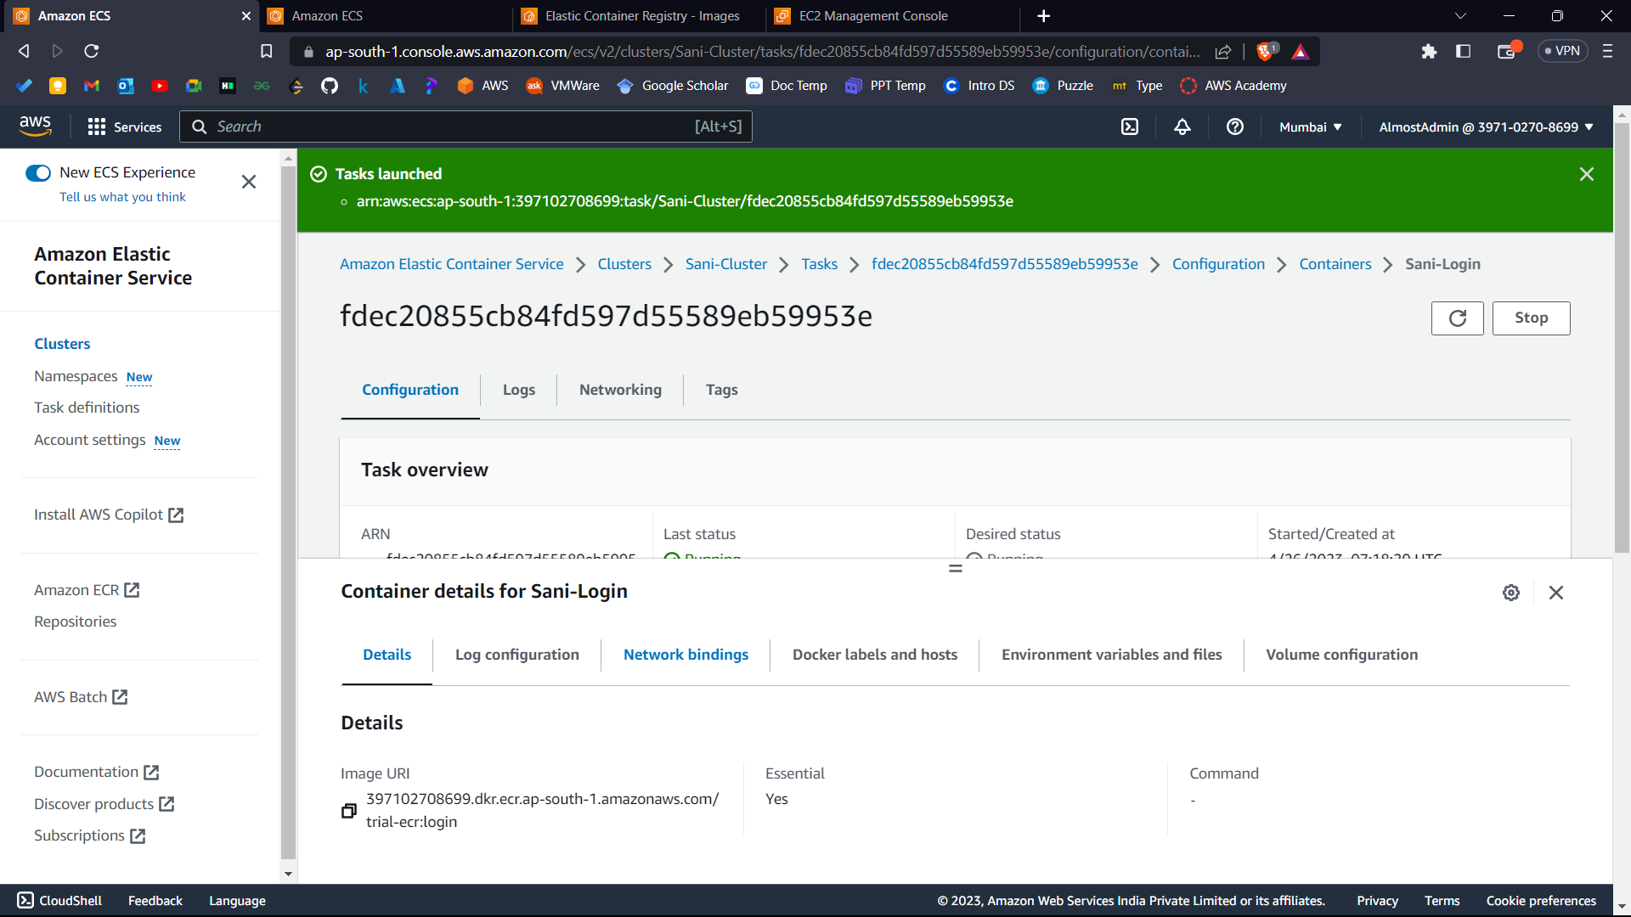



1. Go to network bindings.

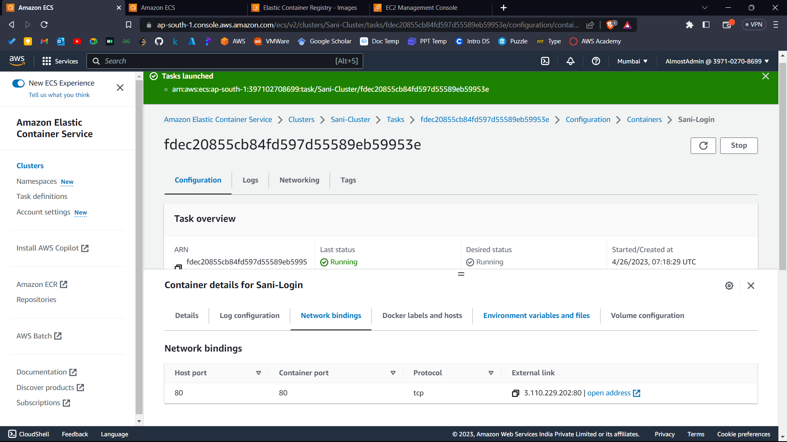



1. Click on open address.

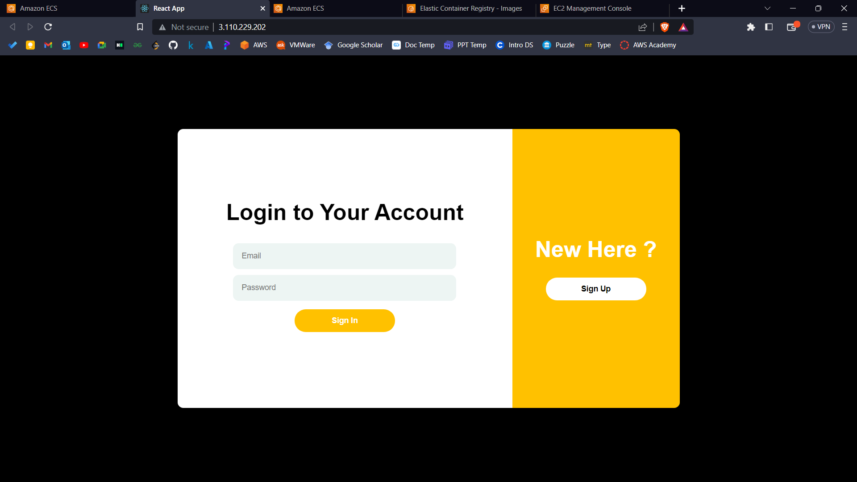

Hurray! Your application is up and running.

**Part 4: - Delete all the services.**

1. Click stop to stop this task.

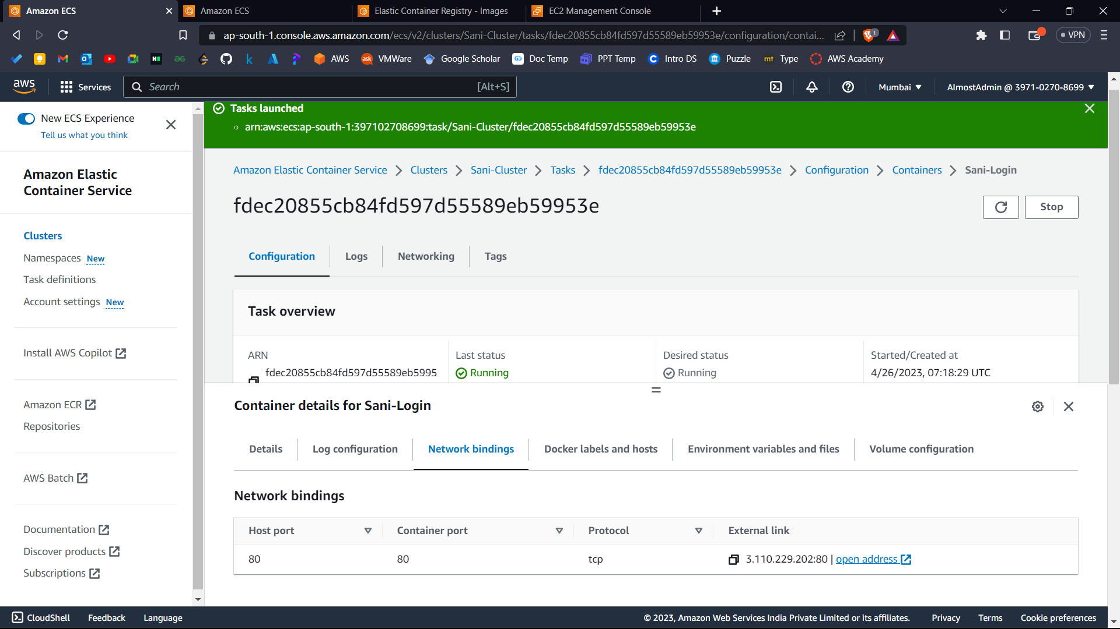



1. Click on delete cluster.

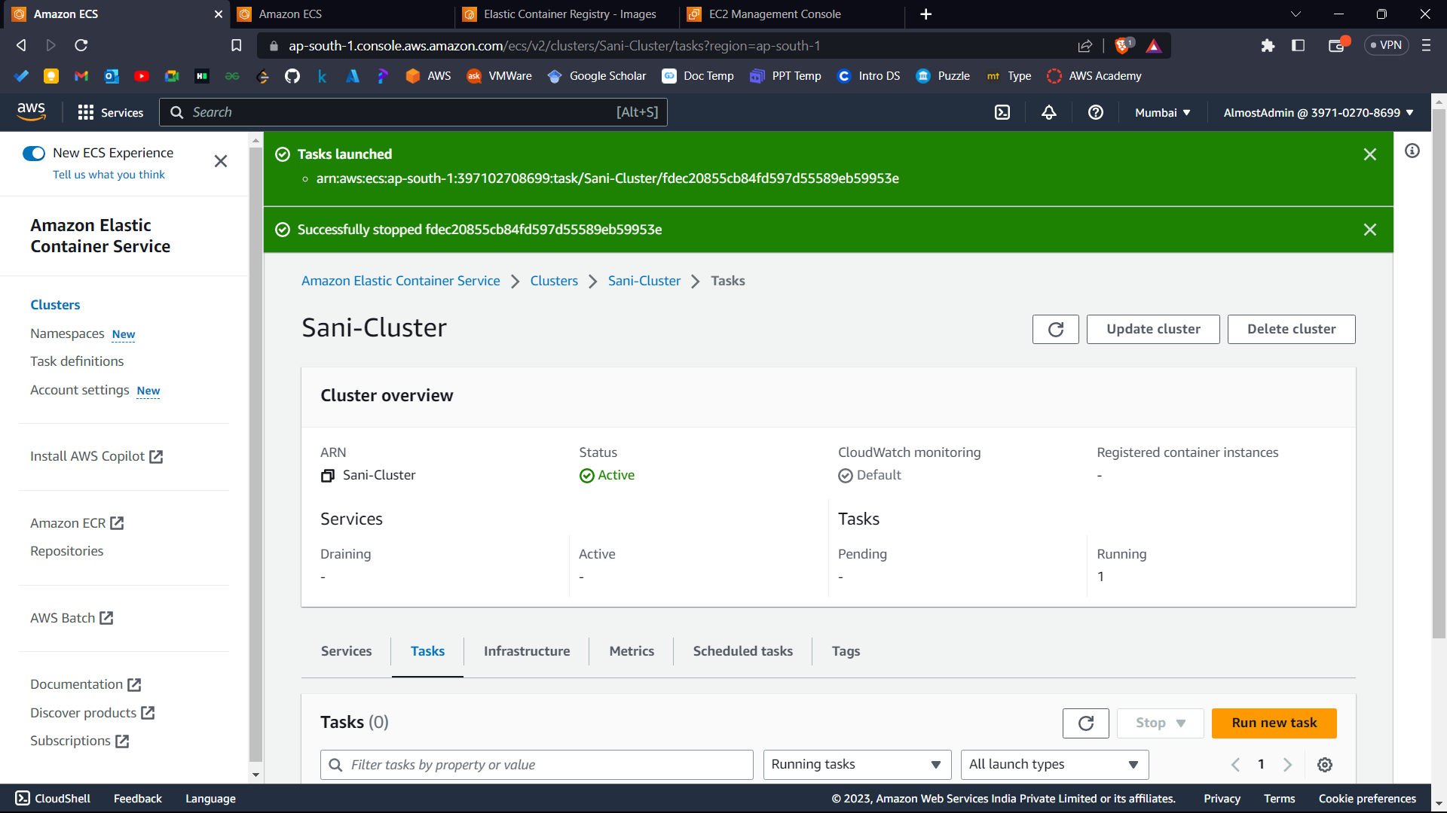



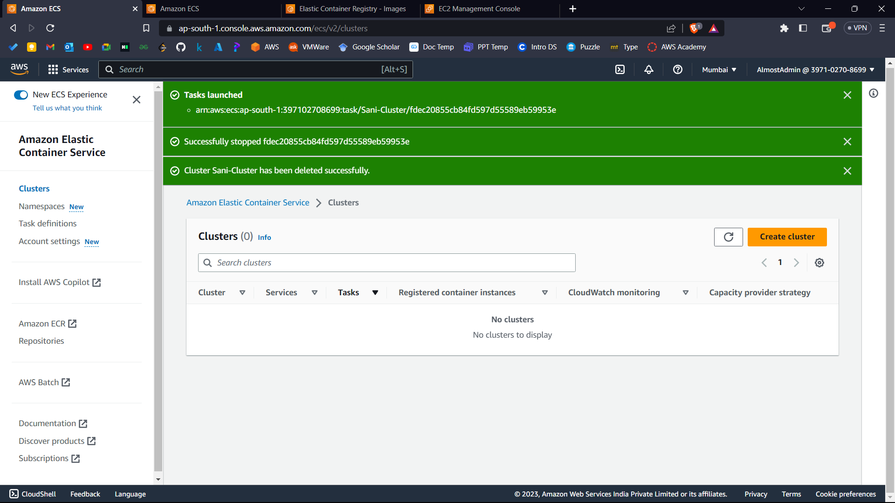



1. Now go to task definitions: -

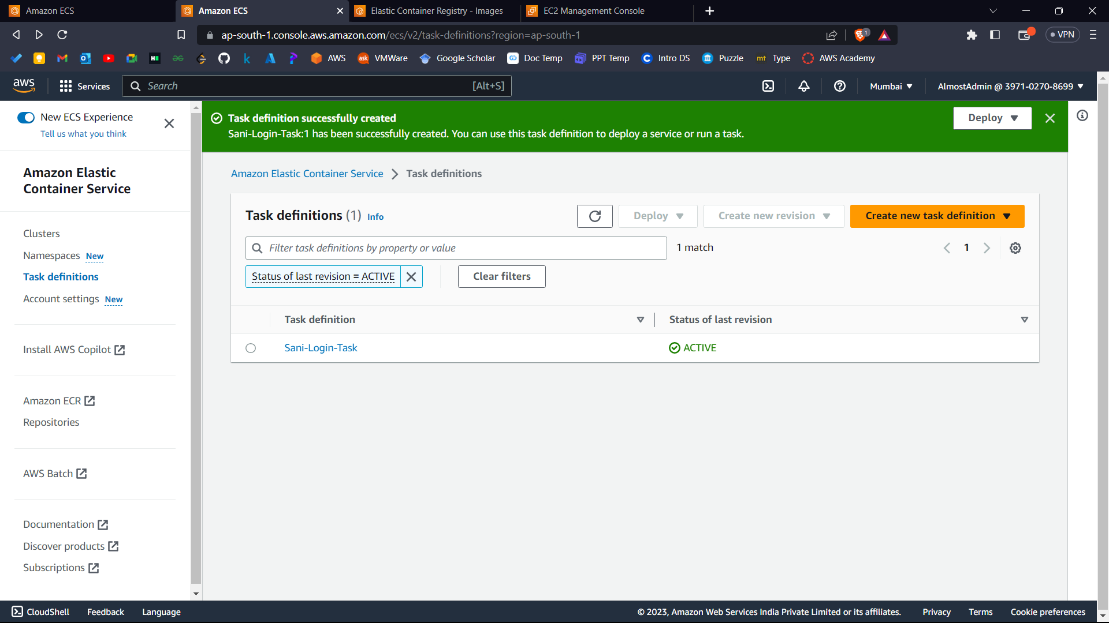



1. Open your task definition.

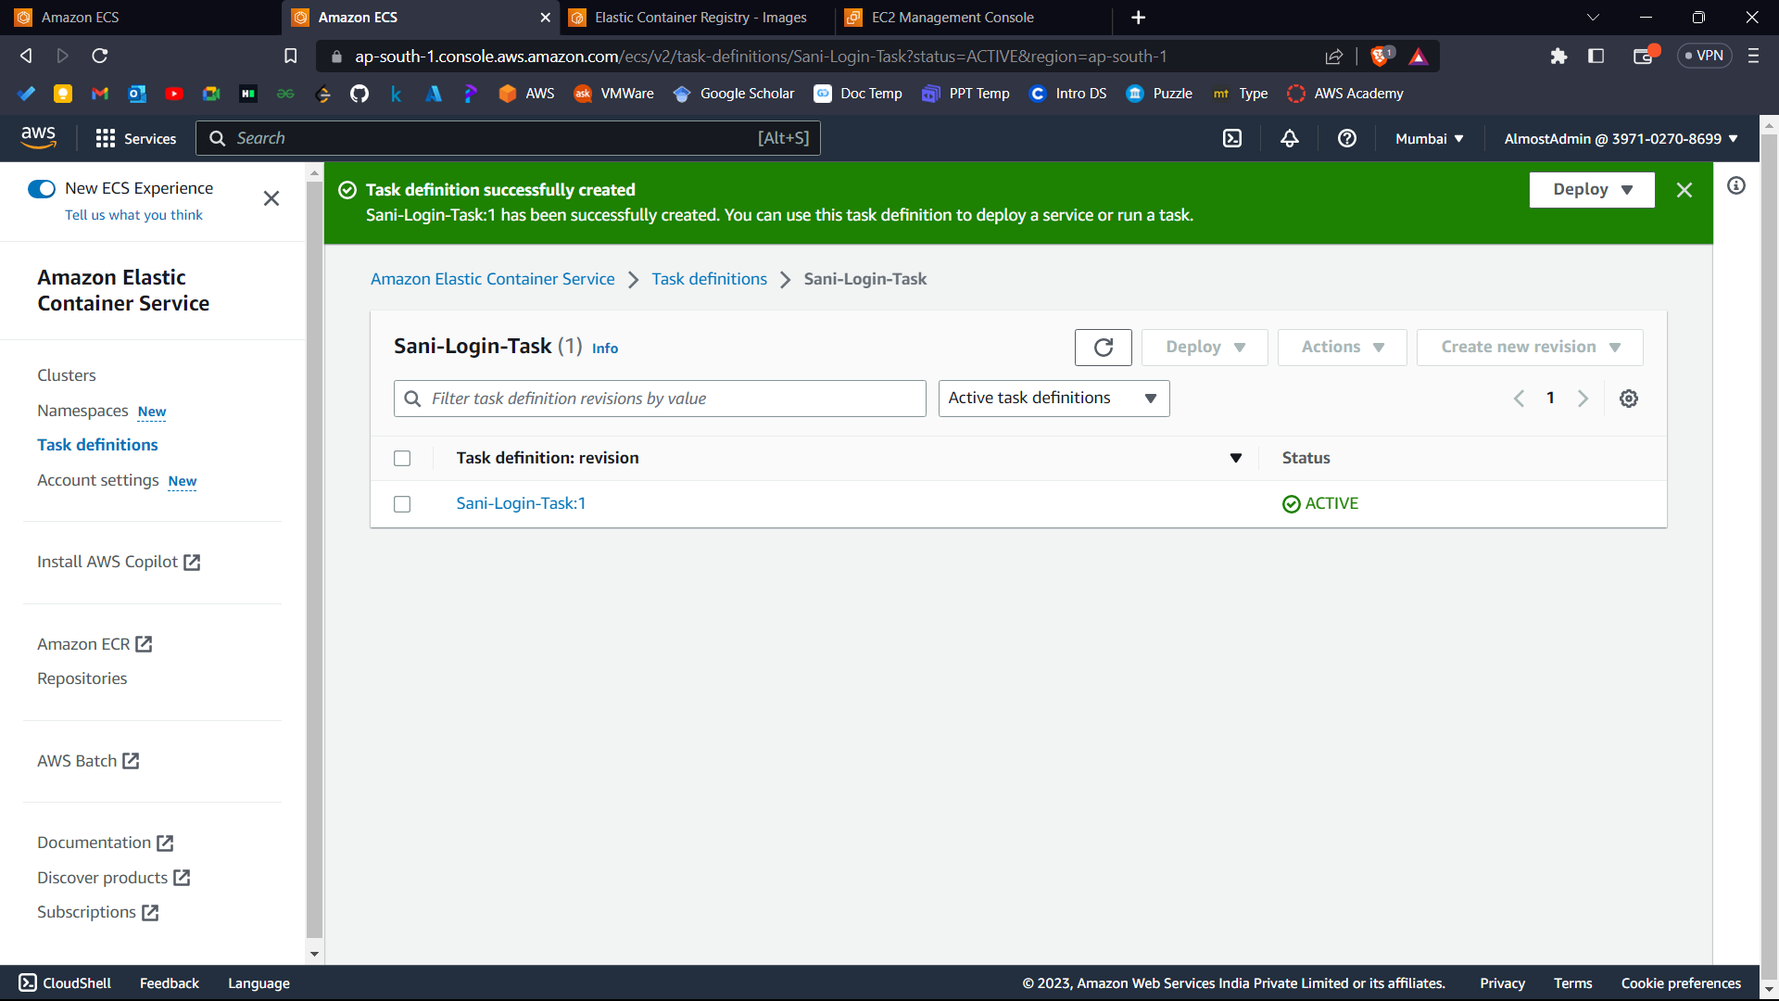



1. Select your revision and go to actions and deregister.

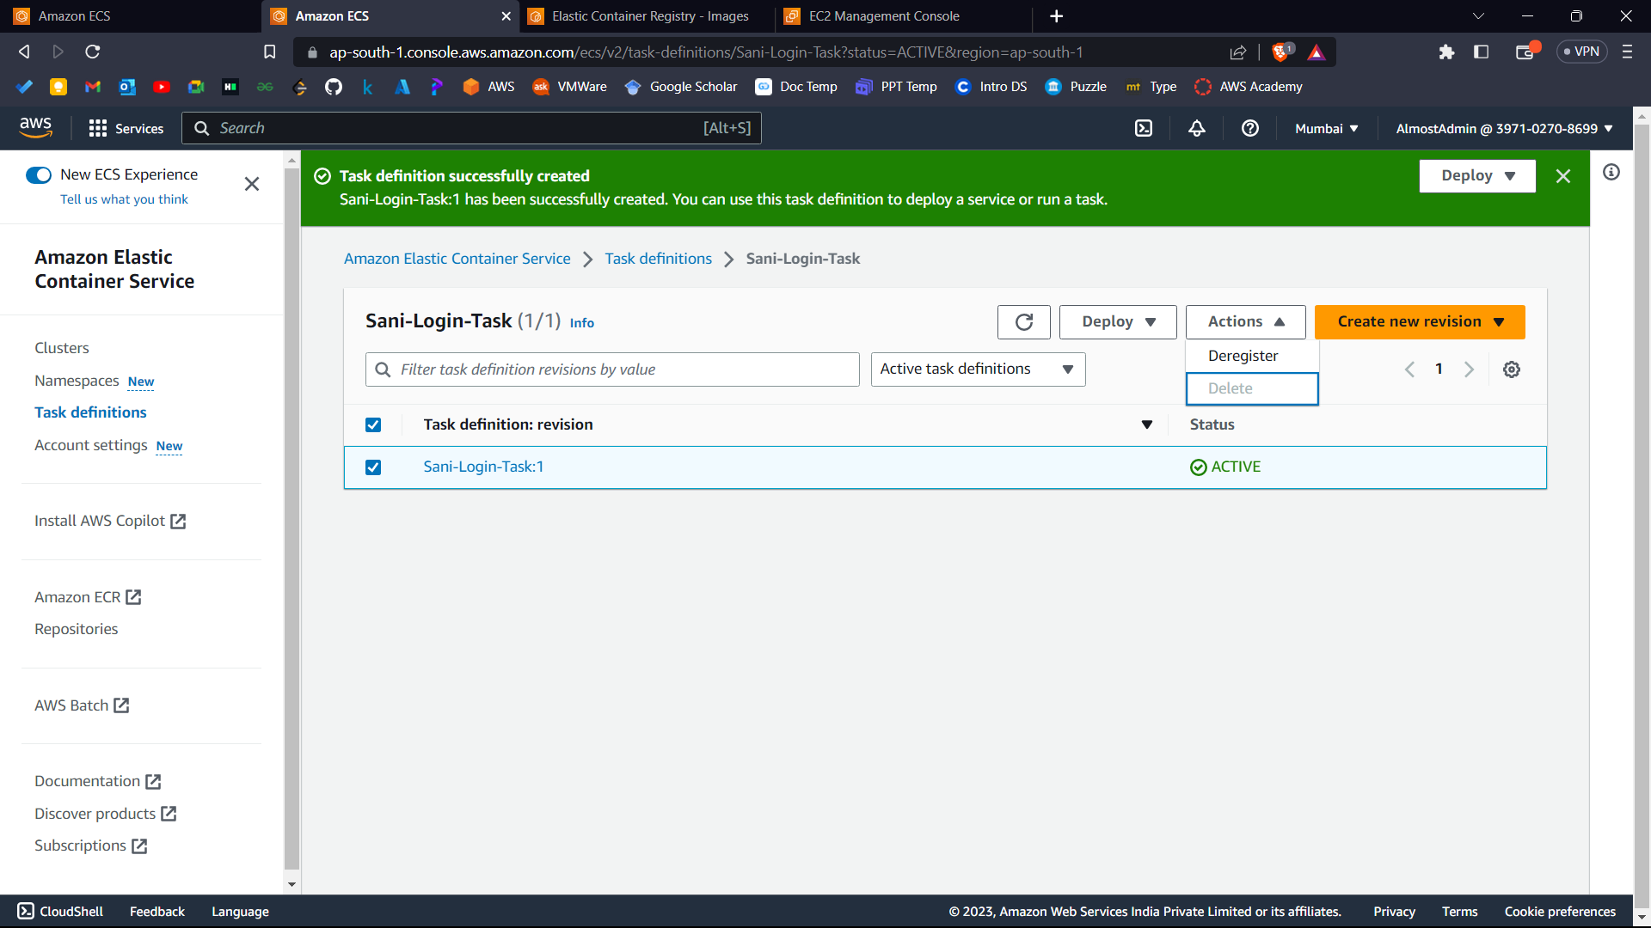



1. Again, go to task definition.

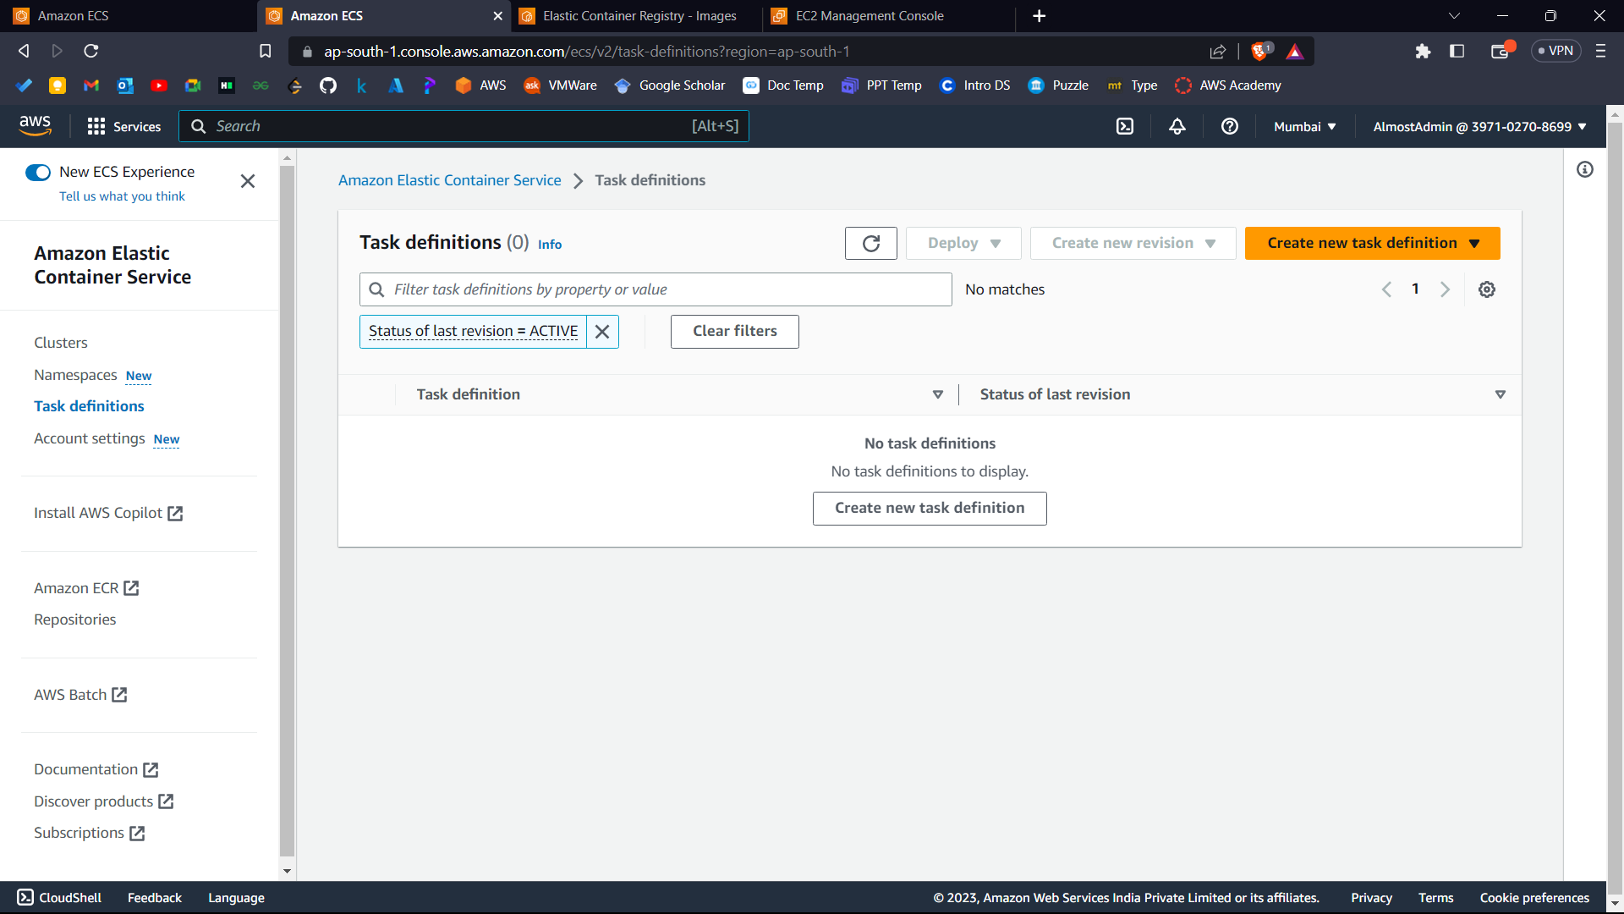



1. Clear the filter.

Go inside the task definition.

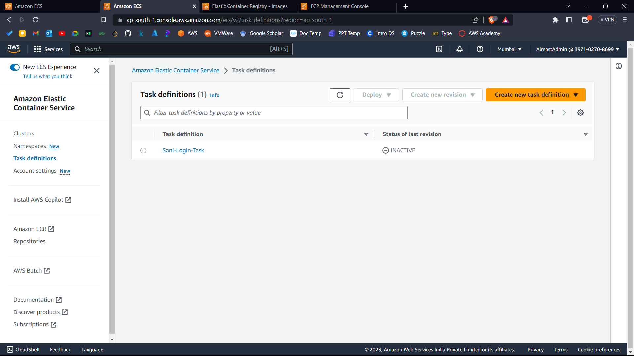



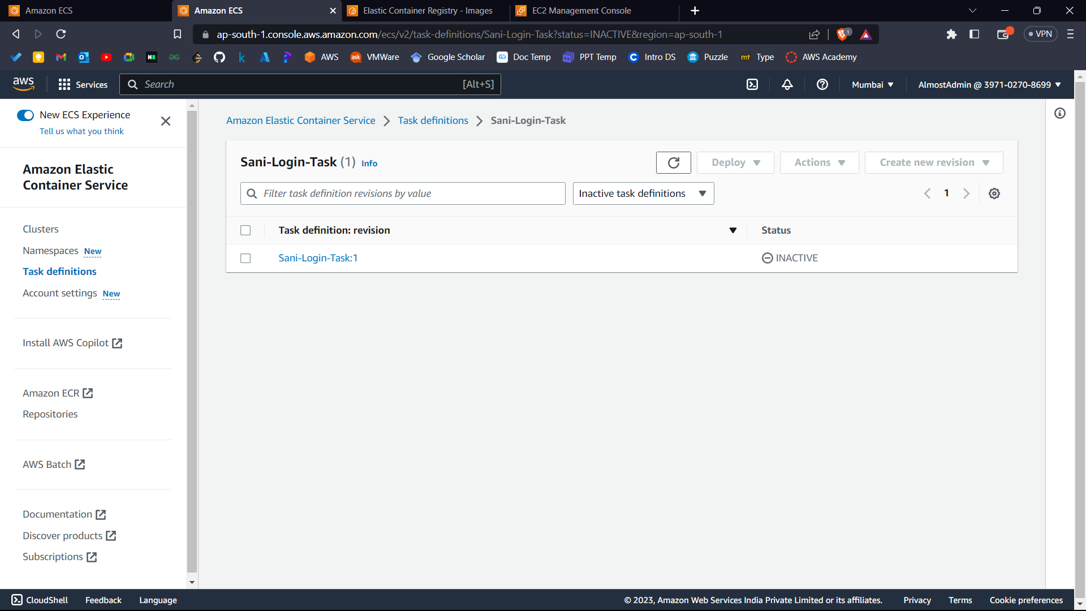



1. Select it and click actions and delete.

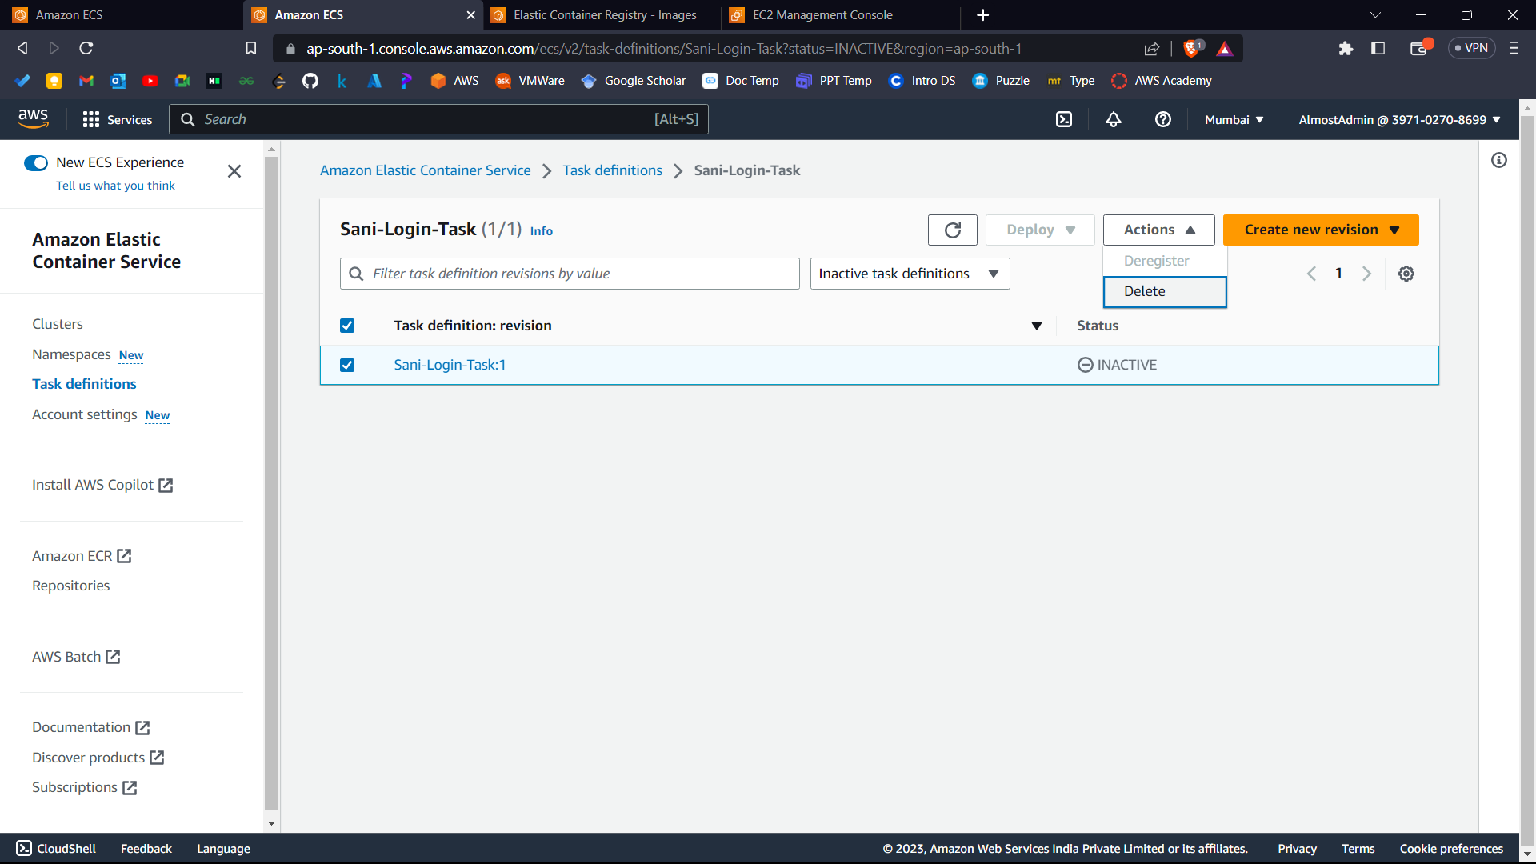



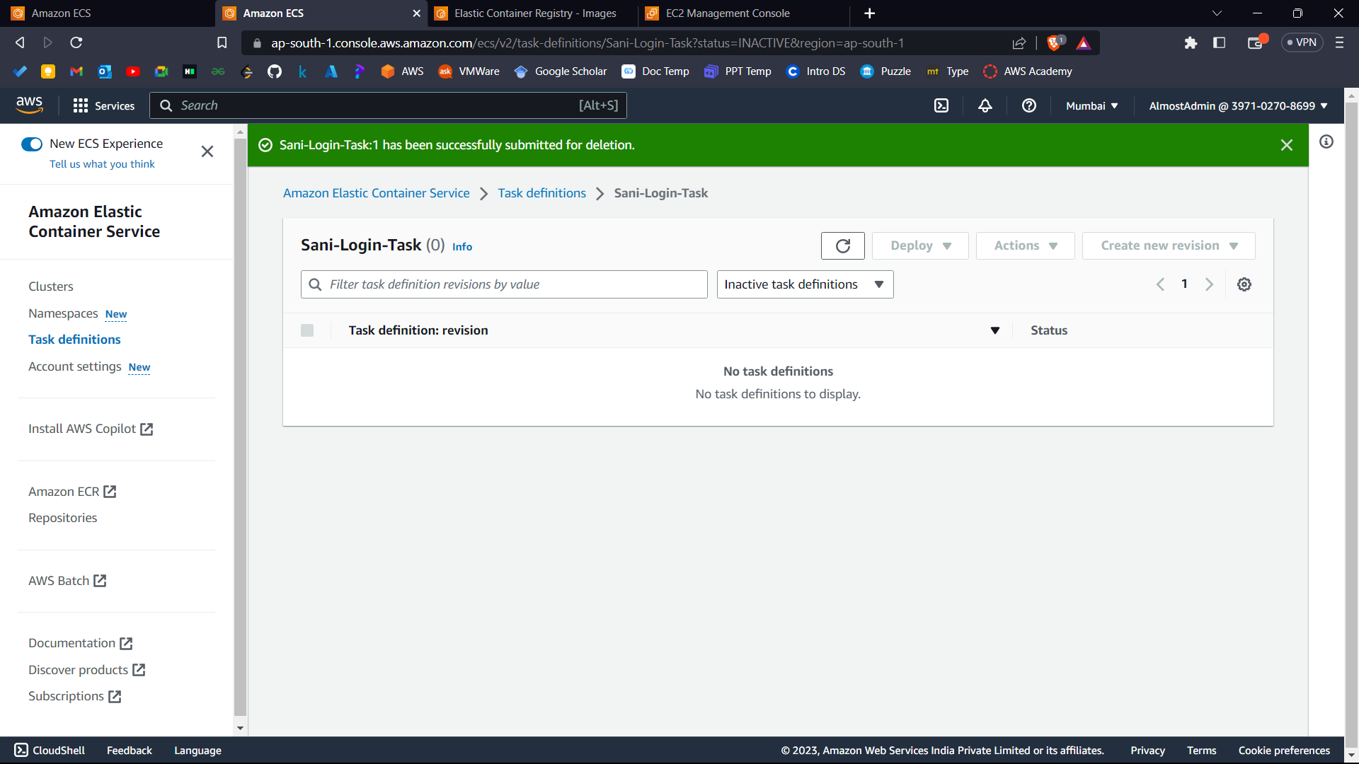



1. Now go to ECR.

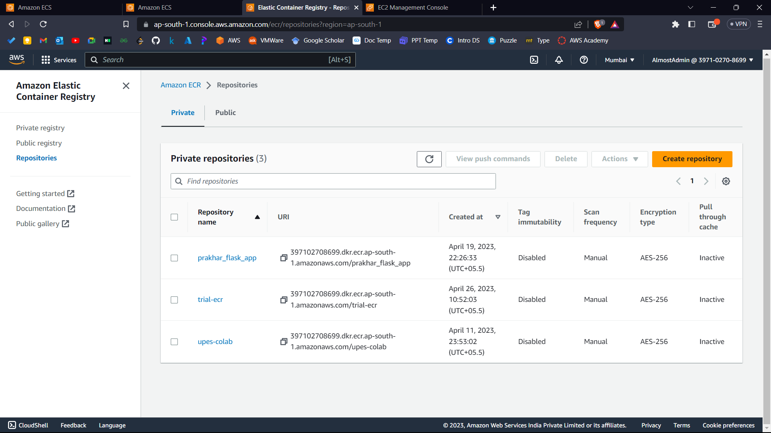



1. Select your repository and delete it.

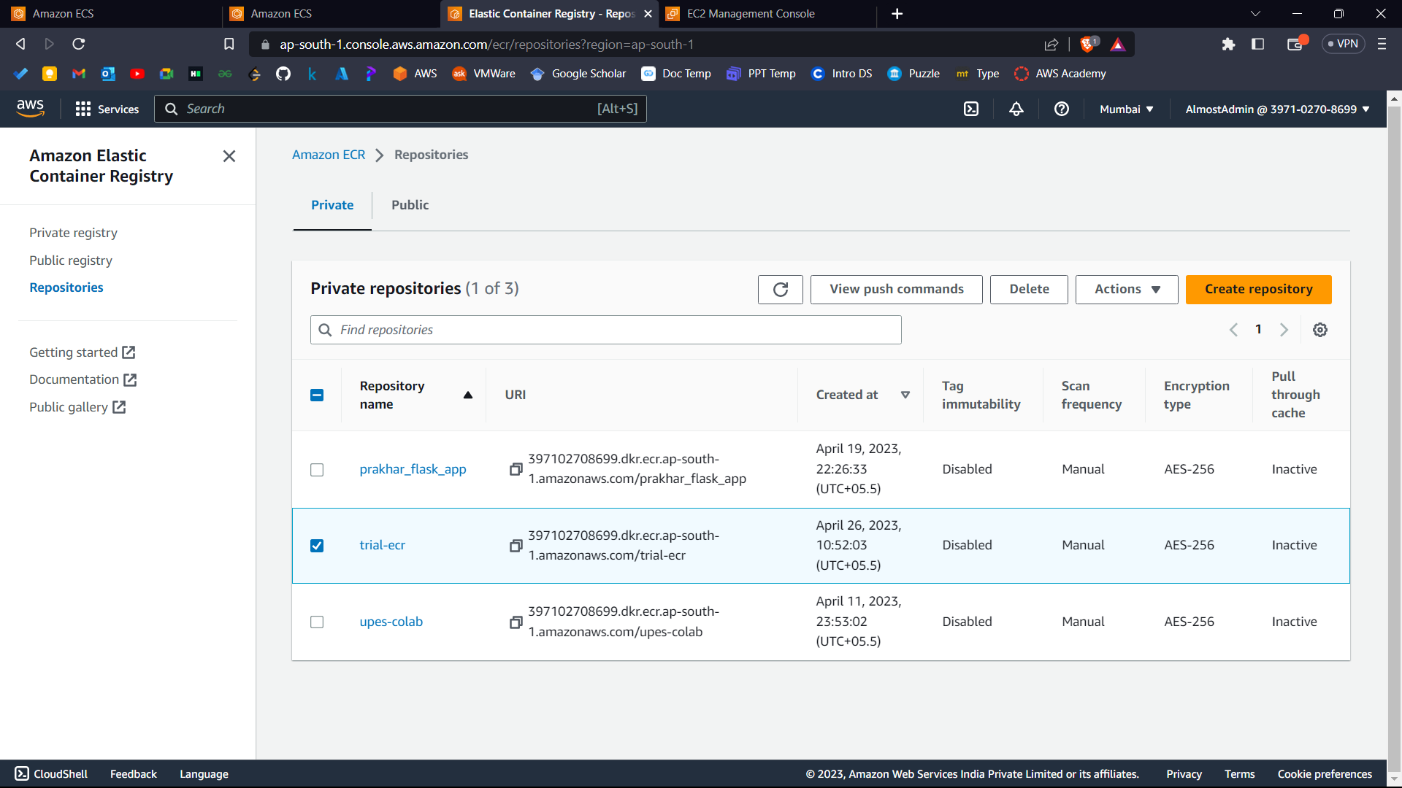



All the resources which can result in generating bills have been deleted successfully!

**\*\*\*\*\***